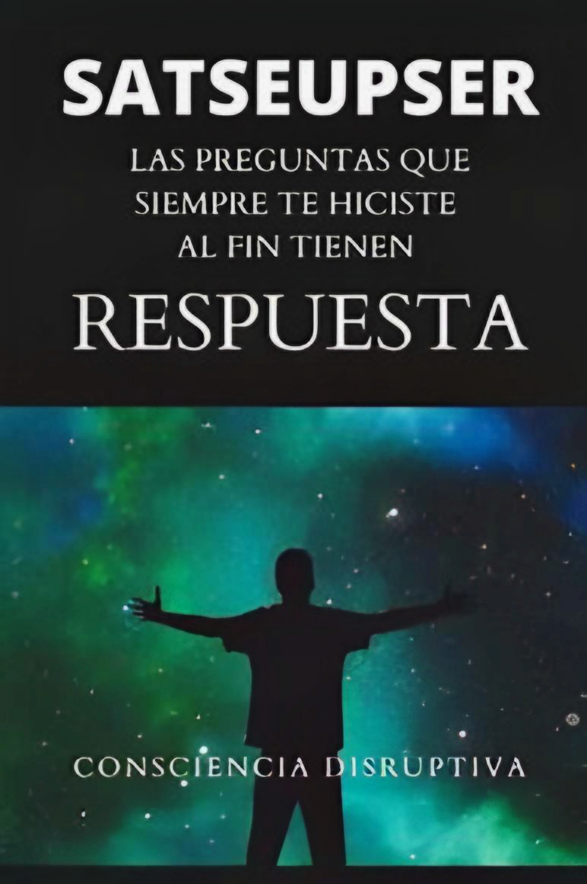

All rights reserved.

**The partial or total reproduction**

**of this work by any means**

**or procedure, including**

**photocopying and computer**

**processing, and the distribution**

**of copies of it by rental or public**

**loan is strictly prohibited**

**without the written authorization**

**of the publisher, under the penalties**

**established by law.**

**TABLE OF CONTENTS**

Acknowledgments

About the Author

Why did I write this book?

**Introduction: -**

**CHAPTER 1**

What are we doing here? What is the purpose of being alive?

**CHAPTER 2**

Why are we “The Human Race”?

**CHAPTER 3**

Is the sun just a star?

**CHAPTER 4**

Is the moon a natural or artificial satellite?

**CHAPTER 5**

Is there life after death?

**CHAPTER 6**

What happened in Ancient Egypt?

**CHAPTER 7**

Many pyramids in the world point to the constellation of Orion. Why?

**CHAPTER 8**

Is there INTELLIGENT life on other planets?

**CHAPTER 9**

What is time? Is time travel possible?

**CHAPTER 10**

Why is there something instead of nothing?

**CHAPTER 11**

My opinion on a historical story: The Bible

**CHAPTER 12**

Is there a single supreme being?

**CHAPTER 13**

Everything is made perfectly: Fate or chance?

**CHAPTER 14**

What are dimensions, who created them, and how many of them exist?

**CHAPTER 15**

Why is a part of our brain known as "reptilian"? Are we reptilians?

**CHAPTER 16**

Why are there other types of races within the human race?

**CHAPTER 17**

Who dominates the human race?

Sources

Gifts on The Last Page

**ACKNOWLEDGEMENTS: -**

Many people made this book possible, but the greatest thanks go to my mother. She was the one who accompanied me and listened to me from the beginning, reading it as many times as necessary, correcting it, and encouraging me.

I don't want to lie and say that I wouldn't have written it without her, but the book wouldn't be what it is if it weren't for her. I want to thank my father, even though he is completely oblivious to most of the questions and answers that are included, he is always there to hug me when I need it the least but I love it the most and to support me in everything I undertake.

I would also like to thank my brother, the person with whom I have the biggest fights and the biggest reconciliations. He is the one who has known how to keep quiet and listen when that is all I need. Who encouraged me from the first minute when I told her about ​​writing this book. I only have words of gratitude and love; these three people have been the ones who have most influenced my life. I also thank my grandmother, with whom we talked for long hours about many of the questions that I deal with in the book and it was through her that I was inspired to put those long conversations on paper. Thank you.

To every person who crossed paths with me at some point in my life, I want to thank them, because whether in a good or bad way, they have influenced who I am today. I am not the past because I do not live there, but I am a continuous succession of present events that were left behind, that are no longer there, but were and will be part of my consciousness. Teachers, professors, ex-friends,

ex-girlfriends, and close friends that I still have today have made me who I am today.

For everything the universe has sent me, everything that has manifested in my life, in whatever way, thank you.

**ABOUT THE AUTHOR**

It all started when I was about 4 or 5 years old. I am not very aware of what I did or the events that occurred during those age periods (as is surely the case for many people) but I have one fact that I have never forgotten. I do not remember the day, but I do know that it was night. I lived with my parents in a small house so everything was sort of connected, that is: kitchen, bedrooms, living room, everything was very close and what connected everything was a hallway, which was dark most of the time. That night my mother was cooking, my father was turning on the stove and I was playing in the living room, where there was a large piece of furniture of those which are used to store glasses, objects to decorate, plants, etc. and this one in particular had a large space in the middle to put a not very large television. The cabinet was facing away from the entrance of the house, let's say that the position was not the best in the world but as I said, there was not much space. If we were in the kitchen, we could see from the hole in the cabinet towards the entrance, and to the right we could see the dark hallway. I was facing the cabinet, playing in the part where the hole was. I don't know why, or how, or the reason, but at one point I turned my head to look at the hallway which was all dark when suddenly I saw a "shadow" like a silhouette that was walking towards me. It was like an instant, that is, the most logical thing would have been to run away, but I can't tell you the reason why I didn't do it. The shadow approached the hole in the cabinet and put its hand on mine. It only held it for a second (that's what I remember). Moments later I calmly went out to where my mother was (she was 2 meters away from me) since she was in the kitchen. According to her words and what she remembers, she says that when I told her what happened, I was not scared or upset, as if I simply did not understand what had happened.

My mother says that I told her something like: "Mom, there is someone in the hallway." After the commotion, my father also heard and they immediately went to see if there was anything there. There was nothing. They also searched the rooms since I confirmed without a doubt what had happened to me. Nothing. Maybe my innocence in this event and that I did not react with fear was for the simple reason that at that age we are totally pure and what we know is what we have been told, and no one had ever told me about paranormal things. After this event, a somewhat similar one happened to me, but in this case, I saw nothing. I went to my room (which I shared with my parents) to look for a toy. Looking under my bed, I felt as if someone grabbed my hand again. In this case, I saw nothing, I just felt. I ran away and went to my mother. Things like this have never happened to me again. Nowadays, I don't look for explanations because I don't think I need them. Although I would like to have them, it's not something I can't live with. I chose to accept it, and if that really happened, it's good that it did and I can tell you about it.

Leaving aside the paranormal, I want to tell you something that marked my belief in beings from another planet, or at least, in what would be the beginning of the fascination with life beyond our planet. I live in a very small town where it is customary to go for a walk around the city every weekend. I was about 9 or 10 years old when what I am going to tell you happened. As usual, my parents and I went out for a walk and touring the streets (in this case we went by car). One Sunday afternoon on one of these walks, my mother or I (I don't remember well) saw something strange in the sky. The object was moving, and although it was not at high speed, it was going fast. My father, who was driving, was immediately interested in the subject and although he could not see it well because the object was seen from the right side, he decided to follow it. Luckily for us, following in a straight line along the main street of the city was enough to keep it in sight. Since we saw it, we must have followed it for 7 blocks or more (about 700 meters) until it reached a point where it stopped.

At this point we were all more than sure that it was not a plane or a satellite, it was simply a **UFO** as its initials define it. We stopped as well. The object was stopped for a couple of minutes when suddenly it made a turn (I cannot describe the movement it made well) and disappeared completely. As if it had propelled itself to who knows where and who knows how. It was a shocking event that made me interested like never before in the UFO phenomenon and I believe that both events that happened to me as a child greatly marked the curiosity I have for any related topic. I have witnessed UFO cases quite a few times.

Then, as I got older, one was more surprising than the other.

I give more importance perhaps to the first two stories because, as I told you, they marked a before and after in my thoughts regarding each phenomenon, since having witnessed that from a very young age, I think it opened my mind completely.

**\*\*Why did I write this book?**

I have always been a person who asks about absolutely everything, it seems like it is a need, but it is only curiosity, a desire to know more, but not to know everything.

Just to know. As I know that the public that is interested in this book are curious people too, I wanted to write a book that I would have liked to read a long time ago. A concrete book but at the same time that leaves me room for doubt, which makes me think so that I can (with the information it provides me) arrive at my own “answers”.

There is not a single reason that I could tell you why I wrote this book. Various events (my own and other people's), documentaries, videos, blogs, films, people around me and people outside me, books and a couple of other things were what influenced and were part of my motivation when writing it.

**INTRODUCTION**

Sitting at my desk, drinking a cup of coffee while my fingers move to the beat of my thoughts, but for a moment I stop and out of so many things that go through my head I now catch one: What am I doing? What am I?

I realize that I can answer those two, but they don't seem so difficult at first: I'm writing a book in a PDF, sitting at my desk, looking at a computer, and watching the letters appear on a blank sheet; yes, that's what I do. And who am I? I'm a 21-year-old guy, black hair, average height and weight, entrepreneur, and well, I could go on. They weren't that hard to answer in the end.

**“Or is it that those answers aren't right?”**

How do I really know what I'm doing? I mean, what I told you before is fine, but it's very mundane. On a personal and material level, I may be just doing that, but if we are composed of millions of atoms and molecules, with a life of their own as well and they are part of me, should I include them in what I'm doing? Should I also include them when people ask me who I am?

I don't want to beat around the bush, although in this book the least you will achieve is to stay in the same place.

I want to give you answers, taken from my own research as well as from great researchers and references, but you will not see the absolute truth. It is not a book where you will come out with things clear, but it will be a book which you will finish and you will not have understood anything at all, but at the same time you will know that you have information that no one has, that you know things that not everyone knows.

I do not expect the reader to understand, the least he should do is try to understand. I want the reader to enjoy asking, questioning and through the play of words, beliefs, questions, investigations, images, and phrases, discover what is beyond everything that surrounds us; or to realize what is the only thing there is.

**CHAPTER 1**

**What are we doing here? What is the purpose of being alive?**

I decided to put these two questions “**together**” because I consider that they basically deal with the same topic: **why we came to this world and what is the reason for being alive**.

I think that asking ourselves what we are doing here, in the world and since we are here, what is the purpose of being here, are some of the most powerful questions we can ask ourselves. If we really ask ourselves, deeply, what is our purpose, there is no way we will not feel our body vibrate. Since I consider that the question “what are we doing here?” can be answered quickly in this chapter (since as you delve deeper into the questions in this book, you will realize that you will be able to give your own answer) I will start with it.

**Let's divide it into three parts**: first, let's consider that we are here for some reason (at the human level), second, let's address this question at the individual level, that is, what each person is doing here. Third, let's state that there is no reason to be here and we will answer it as well (in the community and individual).

(When I use the word "**here**", I am not referring to any place, just that this is the way we can shape the words so that the following paragraphs can be understood later)

**1) We are here for some reason (human level)**

Have you ever thought about what role we all play at a global level in the universe?

Or well, what are we doing here on Earth?

What are billions of atoms doing here?

Buy things? Reproduce? Eat? What do they do?

Before I answer all this and you continue with the book, I want to make it clear that we are not going to answer anything from an earthly perspective, that is even boring. It is that, think about it, if we wanted to we could answer those questions with a **yes** since that is what we do (we buy things, we reproduce, we eat, etc.) but we know that there is something beyond all that, or at least that is what we want to believe.

A part of us (our ego) wants to believe that this is so, we want to have a reason to be, to exist, we want to be here for a reason (and if it is heroic, even better). We would not like at all to know that we are nothing in this vast universe, that we do not fulfill any role in our Earth. The thing is, we are THE HUMAN RACE, how could we not be important? Furthermore, we have a planet (which we love, care for and defend, by the way).

If we all do things together we can do **GREAT THINGS**. I agree with that, but has humanity ever really worked together to achieve anything?

I think that if we have a reason to be here at a community level, it would be to achieve the same level of consciousness. It is not about thinking the same or being equal; **having the same level of consciousness.**

With consciousness, I refer to the capacity that each of us can achieve to be at peace, to be present, to have a level of “intelligence” that allows us to realize that there are no borders, no languages, no religions, no political doctrines that can separate us.

If there is a reason to be here, it is to achieve a new level of unity.

**What purpose would that serve?**

Let me answer you with these questions: Why are there wars? Why is there no global acceptance of others?

2) We are here for a reason (individual level)

As in case one, our ego is in charge of giving a reason for this. Are we here to help thousands and thousands of people? To change the world? He will answer yes, because if I don't do something this big, who will I be?

Our ego does not want to be forgotten, it wants the complete opposite: to be remembered for what it did and said, and for the legacy it was able to leave.

**Is this wrong?**

As my belief supports, good or evil must be questioned by the judgment of each individual. So, on an individual level, each person can have a reason for being, a reason that makes them get up every morning to achieve their dreams, goals and objectives in the world.

3) There is no reason to be here

For some I think it would be a disappointment, I mean, to help so many people for nothing? Change the world for what then?

If there is no reason for each and every one of us to be here on planet Earth, what would be wrong with it?

If there is something that we all know how to do (although not very well) it is to live (sleep, eat, reproduce), we have the basics.

**Anything beyond that, is it necessary**?

If we focus on basic needs, one would not need more than what I have mentioned to you.

Therefore, there may be no reason for us to be on the planet, or for us to be part of the cosmos. In the end, what can millions of atoms in human form do in a universe that seems to have infinite dimensions?

**CHAPTER 2**

**Why are we “The Human Race”?**

Today our species is called Homo Sapiens, which we know very well means “**wise men**”. A term which in itself is meaningless and full of sexism for the simple reason that not all the inhabitants of the Earth are men, but that would be another topic.

In biology, “**race**” is used to define groups with common genetic characteristics, so on the biological side the term is well defined, although some anthropologists maintain that the human species is only composed of one race, which is divided into several **ethnic groups** (people who have similar cultural practices and social behaviors) and these in turn are divided into peoples.

From where I see it, they are just words so that we can “**communicate better**”. But if we want to answer the question of why are we The Human Race? we will have to go beyond simple words and definitions even if these guide us to a result.

Why do we have to call ourselves that way? From whom or from what do we have to differentiate ourselves? On an Earthly level, the term ethnicity and not race is used to divide humans with different characteristics (whether cultural or biological) to eradicate racism, but on a universal level? From whom or from whom do we have to differentiate ourselves?

This is what I mean when I say that they are pure words to achieve “**better communication**”. They are terms created by humans, people who are able to reason like you and me. Why should we believe that? If we need to call ourselves “the human race of wise men” is it because there are other types of intelligent beings in the universe?

As the matter stands, with this simple question we would have no choice but to answer yes, and by answering yes, only by deriving it from a term created by “**humans**” would we affirm the existence of different types of extraterrestrial races, since otherwise we would not have the need to use the term “**human race.**”

**“So why are we the human race?”**

From my point of view, and leaving the reader to form his own judgment, we are the human race because it was necessary (who knows the reason) to give us a name at a global level. They chose to race, and since no one ever questioned it (why would anyone do so?) that term is the one used today.

As we have already said, on an Earthly level there are different types of races or ethnicities (the word and the definition change, but each one of us knows that no person is the same as another, regardless of the “race” or “**ethnicity**”).

What I want to make clear with this chapter before continuing is that to understand something you have to question everything, you have to see what there is from as many points of view as possible, and question even the most obvious and what is not so obvious. Each one of us has that possibility.

CHAPTER 3

Is the sun just a star?

I never imagined I would ask myself this question, but until recently I would say with complete certainty that the sun is just a star, that there is nothing strange there. NASA has always shown us what we want to see, and the sun cannot be an exception.

Is the sun just that giant ball of fire that shines every day and is essential for us to be alive?

Right now, the most certain thing is not to say yes.

Thanks to the website [www.helioviewer.org](http://www.helioviewer.org) we can observe the sun, in the present and the past.

This website (which I invite you to observe) is an online tool for observing the sun based on the image record of the Solar Dynamics Observatory. It allows us to monitor the sun even by the minute.

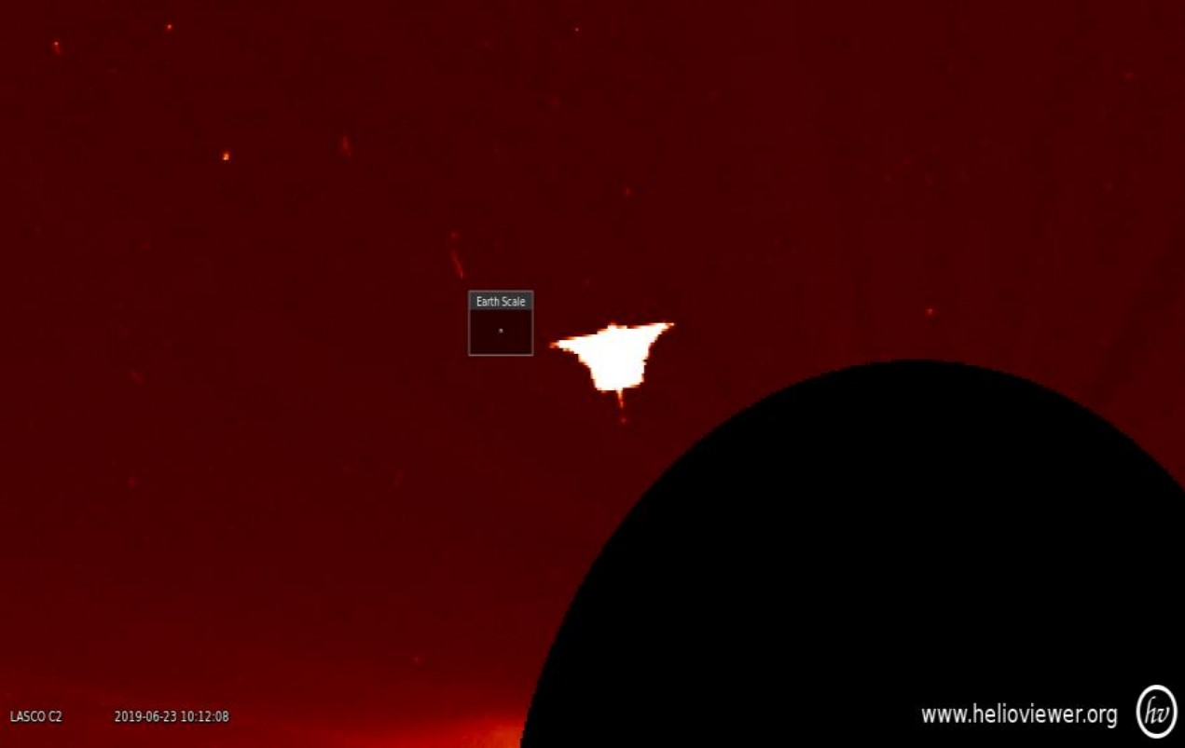

This image you see now is an object found in the tool by **Nacho Rojo** from the YouTube Channel Verdad Oculta, on June 23, 2019, at 10:10 am, where in the video titled “Enormous anomaly in our solar system” he shows us and explains in depth what this strange object is seen in the sun.

The object was there for approximately 8 minutes and then disappeared.

Pay attention to the box next to the object, it is the scale of the Earth…

Like this case, there are more:

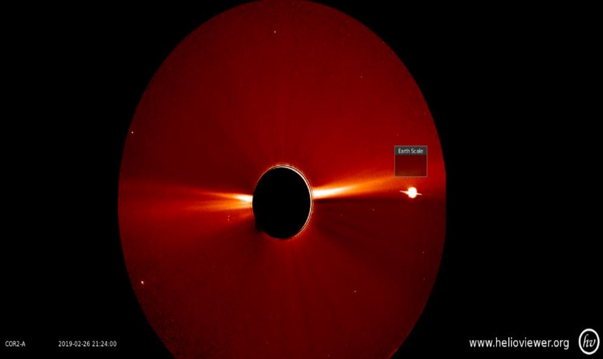

Giant UFO (note the scale of the Earth)

appears on the right side.

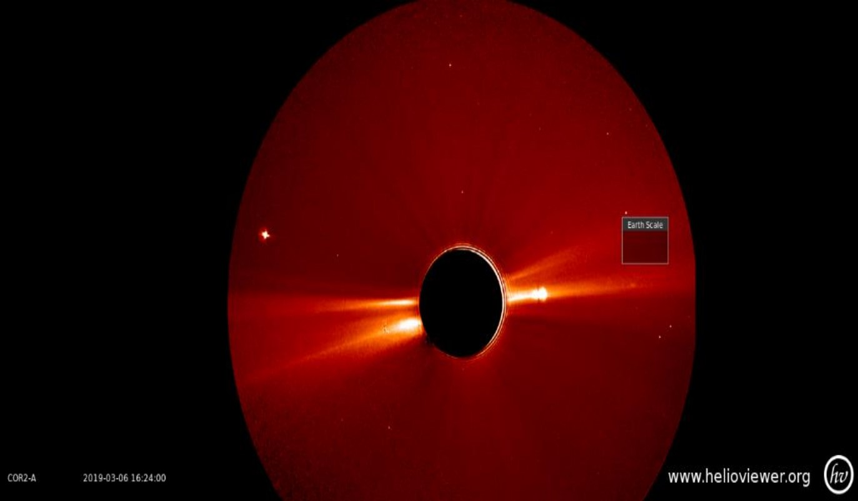

We see how the object on the right is penetrating the sun and we also observe how another object appears on the left.

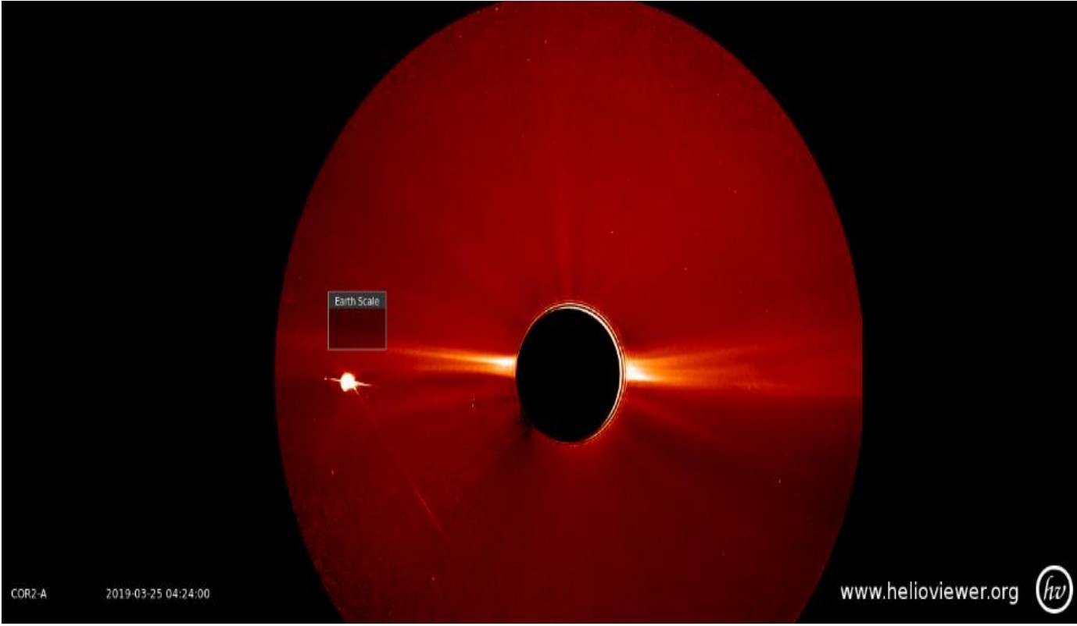

In this photograph, we see how days later the object that we saw in the first of these three images crossed the sun.

To check this, I recommend visiting the website and downloading the film from March 2019 so you can see this process.

The curious thing about all this is that these anomalies Are there, available for any of us to see with just a couple of clicks.

**This can lead us to many questions:**

What are these objects? Are they objects? What are they doing there? Are they manned ships? Why are they near the sun?

And I believe that the most powerful question that encompasses all of these is the one I pose to you as the title of this chapter. Here it is not about denying anything and much less about affirming something, it is about each and each one of us seeing what is there.

In particular, the object in image 1 has a very similar shape to a flying saucer from the 80s. Isn't this very curious? We can highlight its size, which as you may have also noticed with the scale of the planet Earth next to it, is many times larger.

What if that object is in itself a GIANT ship manned by millions of intergalactic beings whose intelligence is capable of creating walking planets that feed on the energy of giant stars like our sun?

**Reality or science fiction?**

Science fiction films are becoming more and more real, even as the phrase says: "Reality surpasses fiction."

So, the best thing today is to refrain from stating anything, and rather enjoy the new discoveries. The only people who will suffer are those who were asleep, those who decided to close their eyes to what they were seeing by closing their eyes to their beliefs.

**The closest we get to an answer is Bob Lazar** (a person who claims to have worked from 1988 to 1989 as a physicist in a military zone called S-4 (Sector Four), located near Groom Lake in Nevada) who tells us about his work with extraterrestrial ships and particularly with element 115.

Bob says that the ships had a generator of gravitational waves in the center, which allowed them to feed a series of reactors which were directed in one direction or another and emitted gravity waves with enormous power that allowed the craft to move at enormous speed.

The interesting thing about this is that element 115 (Ununpentium as Bob calls it) was discovered in 2004, calling it Moscovium, but this element is now considered **unstable**.

According to Bob Lazar, aliens said that this element was **extracted**

**directly from the heart of stars**, which was the only way to find it in a **stable manner**.

So, could it be that what we see in the images are really alien ships (manned or not) created by intelligent beings from some remote place in the universe? And that these ships are powered by the Sun's energy?

The images are there, and any witness who worked in **Area 51** also exists, proves that element 115 EXISTS as well…

At this point, the question has already been answered, let's move on to the next one.

CHAPTER 4

Is the moon a natural or artificial satellite?

Nafi Toksoz, a geophysicist at the Massachusetts Institute of Technology, concedes that “it is much easier to explain why the moon should not be there than to explain its existence” from the book “The Early Earth.”

As we have been told, the moon seems to have been formed in a completely natural way due to the collision of a planet the size of Mars and Earth, but this is still a theory that is not entirely true.

Science is based a lot on studies and observations, which seems to be the closest thing we have to the truth, but even so, many of these investigations end up being theories without a 100% concrete answer.

**The truth is that the more we know about something, the less we know about that something.**

As I see it, humans have not discovered even 1% of everything that there really is.

And you still want to believe something?

To believe in something today is to be willing to change that belief the next day, in a world where everything changes so fast, no one is safe in the truth of their beliefs, and less, if they are backed by science.

**How old is the moon?**

In reality, the exact age of the moon is not known,

although it is estimated from rock samples that it is 4.53 billion years.

In Tibetan chronicles as well as in Slavic legends, it is read that in antediluvian times there was no moon in the sky. In the Bible (Psalm 72): “You were feared from the time of the sun and before **the time of the moon**”

**Is the moon hollow?**

The great scientist Carl Sagan said that “a natural satellite cannot be a hollow object. So, what that means is that if it really is hollow, it is not a natural satellite… and therefore it is artificial.”

The hollow moon theory arises because of its density (3.3) compared to the density of the Earth (5.5) which would indicate that the internal regions of the Moon are less dense than the exterior, giving rise to the inevitable speculation that it could be hollow.

In addition to this, the moon has hundreds of craters, but the curious thing is that they all have the same diameter and depth and when the astronauts tried to drill inside them they were barely able to get deep into the surface.

The astronauts managed to bring back rocks containing bronze, mica, titanium, and the elements of uranium 236 and neptunium 237, which are not elements of nature, that is, **they were created artificially**.

At a scientific level, the question of whether it is a natural or artificial satellite would already be resolved, but we are going to go further.

**Was the moon artificially placed in Earth's orbit?**

It seems that neither its size nor its orbit matches what it should be if it were really natural, so at this point, the supposed collision of the Earth and another planet for the formation of the moon is more than in doubt.

**The great fraud of 1969 or the perfect proof that there is NTELLIGENT extraterrestrial life on the moon?**

Behind the missions that were carried out in those years, there are many conspiracy theories that test whether the moon landing actually occurred. One of the biggest questions we ask ourselves is why have they not returned to the moon in 50 years?

This seems easy to answer for them since they claim that it is due to money and also socio-political issues, in short there is no longer much interest in going to the moon. After this, the conspiracy theories seem to be nothing more than that, since there were 9 missions that took place between 1968 and 1972, so if someone wants to analyze and question something, they have a long job. If it was a fraud, it was the biggest fraud of all time, but we are far from stating something like that.

**The most obvious proof?**

During the trip there were two minutes of video and silences on the radio, when the cameras and recording equipment had a "simultaneous failure," but it happens that it produced perfect image and sound effects for the rest of the mission. Years later close friends and relatives revealed what Armstrong said about what really happened in those minutes. Armstrong turned off his line and said, “There are other spacecraft here, sir, lined up on the other side of the crater. Those kids are huge, they are huge, they are watching us.”

Many viewers wrote to the media explaining that they saw one of the astronauts pick up what appeared to be a glass bottle, but that immediately afterward the television screen went blank. Other viewers also observed that the astronauts had extreme difficulty drilling down a few meters into the Moon, and that when the drill was withdrawn, metal shavings appeared.

There is no complete publication of this classified information, but it is there. We can safely judge and doubt because of the dubious things that happened on these missions and because of what did not happen afterward. But what is difficult to question is when human behavior is so obvious that the truth escapes through the pores.

When the astronauts returned and were interviewed, their behavior was completely different from what was expected, since everyone thought they would see emotion in their eyes, but they expressed nothing but fear and doubt, as if they had seen something they had never imagined, and by the way, they could not tell anyone.

**Why do we never see the dark side of the moon?**

We have already mentioned that there is no logically scientific way to ensure that the moon is natural, and based on this, the questions increase.

The moon simultaneously rotates on its own axis and rotates around the Earth. Both movements are synchronous and last approximately 28 days. Therefore, **the moon always shows us the same face**. However, this phenomenon is completely unique in the known universe. Strange, isn't it?

**Manipulation**

Dr. Donna Hare has witnessed firsthand how information is manipulated within NASA.

This woman worked for 15 years as a technical illustrator for the space agency. In an interview, she said that when she was in contact with one of the Apollo astronauts: “the astronauts saw ships on the moon when they landed, and that she was also afraid to say that the astronauts were asked to be quiet.”

In addition to Donna, another witness to the photo manipulation is Sergeant Karl Wolfe, who claims to have seen photographs of bases on the dark side of the moon.

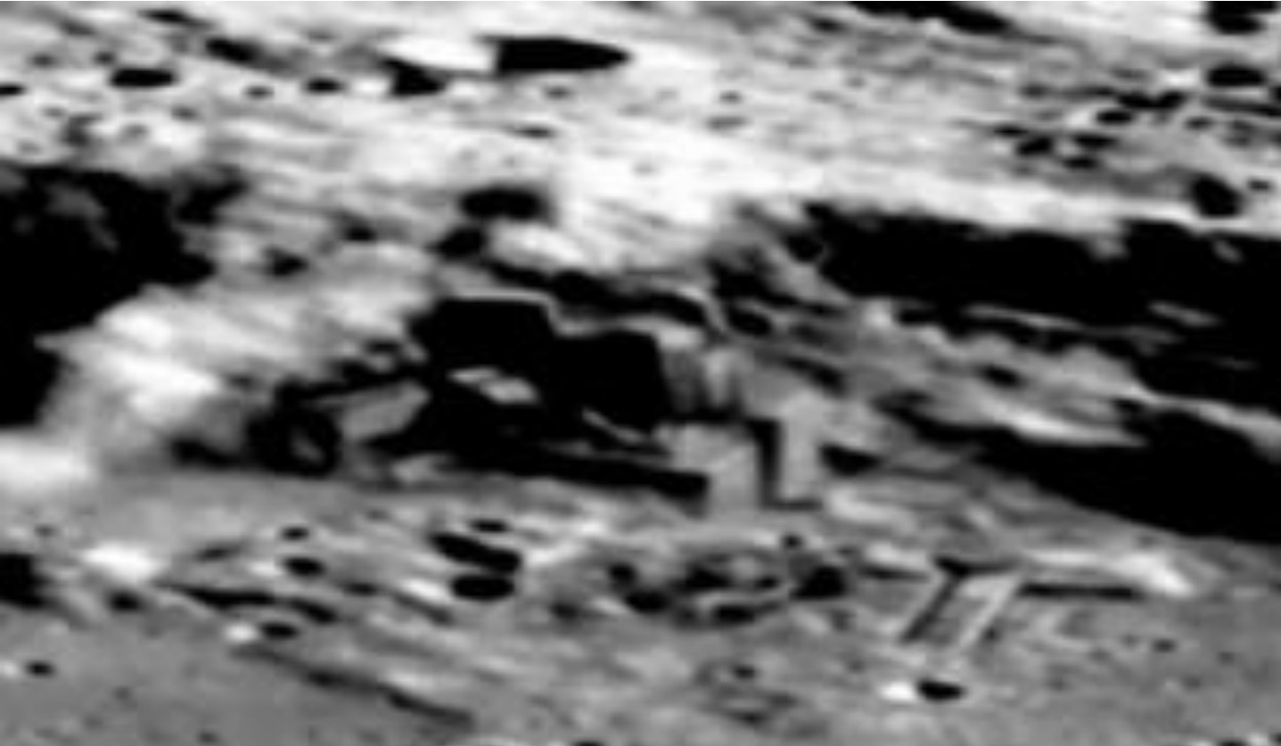

**Bases on the dark side of the moon like the ones Karl Wolfe claims to have seen.**

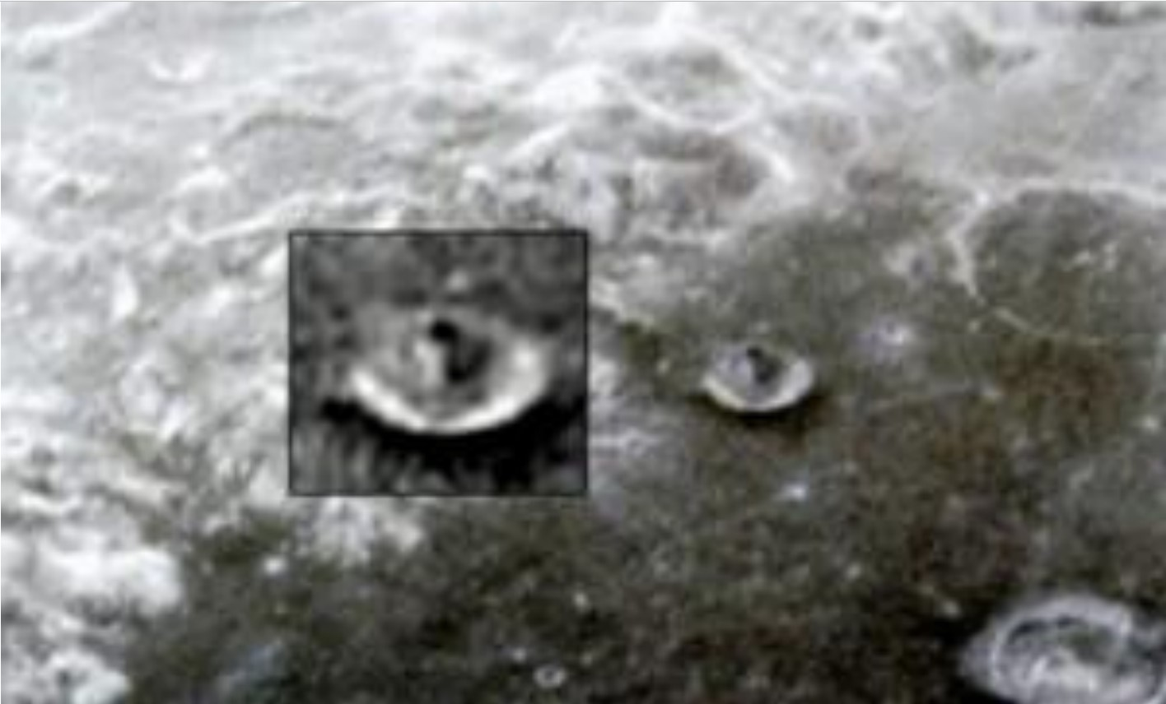

**Construction on the dark side of the moon.**

It is a fact that throughout history and the present we live in, NASA shows us what it wants to show us, not what is really there.

And this ended up being more than obvious when in a statement NASA said that public information about extraterrestrial life could cause the collapse of society, and therefore should remain clandestine.

From our side and with a highly critical opinion, it is more than obvious to us that doubting everything we have seen is the safest thing we have, and if we want to find the truth in something it is through witnesses and inconsistencies caused by the excess of lies and the excess of hidden information.

As I have said in previous chapters, as we decipher the other questions, you will realize that everything there is points to practically the same thing.

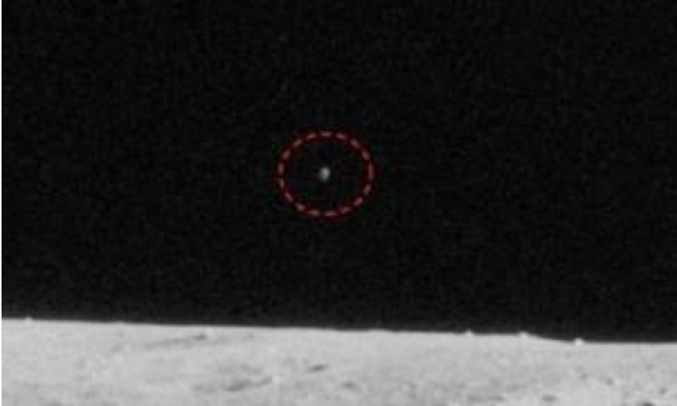

UFO recorded by Apollo 12

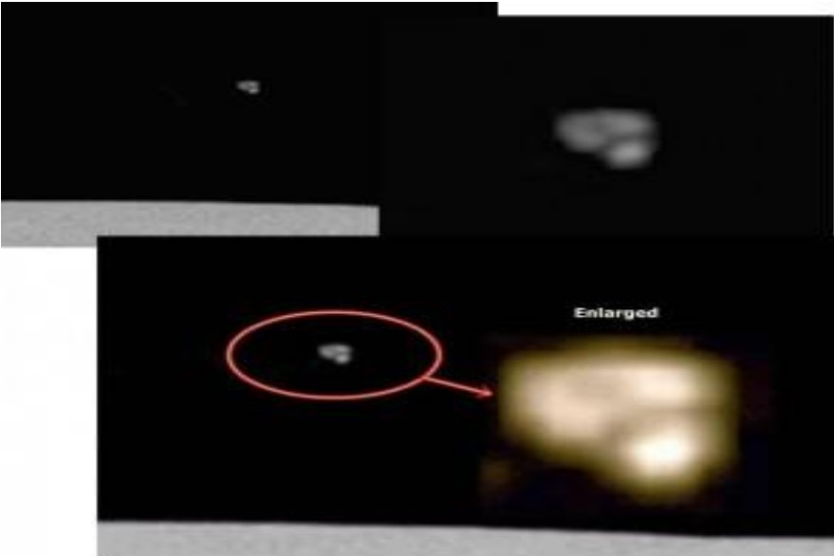

Zoom UFO Apollo 15

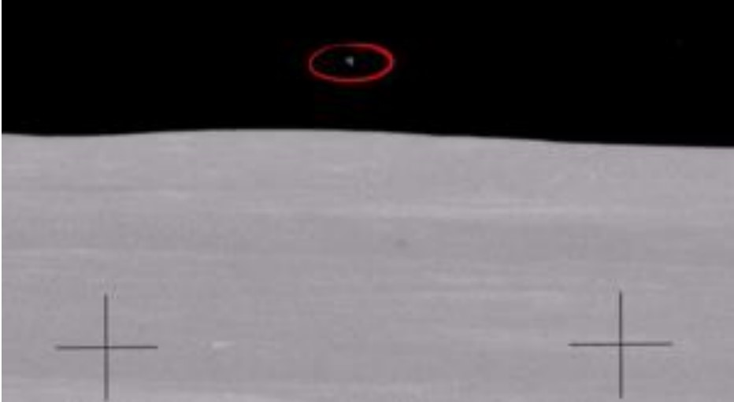

**ARIES Apollo 15**

With all this in mind, with all sides of the coin seen, it seems that the position in which most of the population finds itself is on the lower side, unable to know the absolute truth of what is happening out there.

In the very near future, human beings will become intergalactic and many of these questions that today seem to flood us with doubts will be the most real thing we have ever thought.

There are no two without one, just as NASA would not have the need to hide and distort images if there was nothing behind them (which it has already confirmed).

To close this chapter, I want to say that the moon thing was a great step for man, but a giant lies for humanity.

CHAPTER 5

Is there life after death?

It would be crazy to think that there is, right? From the moment we are born, it is clear to us that we are going to die, that life is simply a one-way path with an end…

**But is that as clear as it seems?**

Life after death is one of the most mysterious and often even taboo questions we can encounter.

**What do ancient cultures tell us?**

The famous Bible tells us that after we die we have heaven or hell.

Hinduism tells us that when we die we are reincarnated.

**What does science tell us?**

To study this phenomenon, scientists focus on studying NDEs (near-death experiences).

A very famous scientist on this subject, Dr. Raymond Moody, wrote a book entitled Life After Death, where he stated that all people, regardless of their culture or religious beliefs, after being clinically dead and coming back to life, recounted practically similar experiences. The most commonly described experience was a feeling of peace and seeing a tunnel of light. For many people this was strong proof that there is life after death, but for others this could be due to a lack of oxygen, which would cause these hallucinations.

In his book, Stephen Hawking answered the question of whether there is life after death by saying: “Just as there is no God, there is no heaven or afterlife to live in after death. **I believe that believing in life after death is an illusion.**”

**What if death is just a creation of our consciousness?**

This question is not as far-fetched as it sounds, since it seems to even have an answer through quantum physics, and specifically in the new theory of biocentrism that supposes that death cannot be a terminal event, as we have always considered it. The concept of death is a mere product of our consciousness because we associate with our body and we know that physical bodies die (Do you remember chapter one where I talked to you about the ego?)

If we bring quantum physics into this question, it tells us that it is not that there is life after death, it is that death does not exist (quantum immortality).

Quantum physics is based on the theory of parallel universes, which suggests that any time a universe is faced with a choice of paths at a quantum level, it is actually following all the possibilities, splitting into multiple universes.

Which means that there is no possibility that anything will end, further affirming the fact that death is a product of an ancient belief established and rooted by all of us.

**What about death then?**

We cannot refrain from believing one thing or another, not yet since there are still a couple of facts that I want to show you, but we are getting closer.

**Reincarnation**

As I mentioned at the beginning of this chapter, there are many cultures that believe in life after death, but others believe that, even if we die, what dies (stops working) is our physical body, so our subconscious mind or “**soul**” continues “**alive**.”

The theory of reincarnation is not so far-fetched for the simple reason that it is supported by what science has told us.

According to Lavoisier’s famous law, energy is neither created nor destroyed, **it only transforms**, and I want us to stick with this.

The human body is made up of millions of particles, all of which have energy.

Deducing: we are energy, and energy only transforms, it is not destroyed, which would be the same as saying that… it does not die.

To this we must add the hundreds of cases of people of different ages who tell who they were in past lives.

**Here is an example:**

Patrick Christenson was born by Caesarean section in Michigan in March 1991. His older brother Kevin had died of cancer twelve years earlier at the age of two. Early evidence of Kevin's cancer came six months before his death when he began to walk and had a noticeable limp.

One day he fell and broke his leg. Tests were done, and after a biopsy on a small nodule on his scalp just above his right ear, it was discovered that little Kevin had cancer that had metastasized. Tumors were soon found growing elsewhere in his body. One of these tumors led to blindness in one eye.

Kevin was given chemotherapy, which caused scarring on the right side of his neck. He died three weeks after his second birthday. At birth, Patrick had a birthmark that looked like a small cut on the right side of his neck, exactly in the same place as Kevin's chemo scar. He also had a nodule on his scalp just above his right ear and a cloudiness over his left eye. When he started walking he was a little limping.

**When he was almost four and a half years old he told his mother that he wanted to go back to his old orange and brown house**. This was the color of the house the family had lived in in 1979 when Kevin was alive. He then asked her if she remembered having surgery. She said she couldn't because this had never happened to him. Patrick then pointed to a spot just above his right ear.

**He added that he did not remember the actual operation because he was asleep. The boy's entire account was consistent with the details of Kevin's past life.**

Like that case, hundreds more can be found on the Internet, but if you would like to read some that have research behind them, I recommend you read the book: “Twenty cases that make you think about reincarnation” by Ian Stevenson.

Lavoisier’s law will accompany us in other issues that we will address in the book, as well as it should be clear to you from this chapter that everyone and everything around us is composed of energy (particles at a microscopic level).

We will never be able to deduce something as **100%** true, but what we can do is what you have seen in this chapter, gather all the information from all the possible areas that deal with the same topic, whether they are contrary or not, to see which ones have more weight and once that is decided, join them to conclude something.

In this case, life after death cannot be verified by anyone, but it is not necessary to verify that.

I was once told that to solve a problem or an issue you should not focus on the problem; the problem is the problem and that is it. If we want to solve something we should focus on the solution and deal with it from the outside, that is, look for a way to solve it without focusing on it, as we have done with this question.

I am not trying to directly answer your question of whether there is life after death or not, because I would be giving you my opinion, my beliefs, and sharing a belief is very easy. What I want you to take away from this is that we have to understand all the information, and as I have also mentioned, you will increasingly realize that everything is connected and points to the same thing.

CHAPTER 6

What happened in Ancient Egypt?

There are many mysterious events that occurred in Egypt, but none of them compare to the great pyramids that we all know.

For many years, doubts have been cast on them and theories have been created around them.

**Were the Egyptians really the ones who created the pyramids?**

“The largest pyramids were built by our ability to use the forces of the One. The stones are alive. It is something that has not been understood as much because of the mind/body/spirit distortions of

your culture.”

**–Excerpt from the book The Law of One.**

There is a great debate about how they were created to know how they managed to move the huge rocks weighing more than 2 tons, and how they managed to do it with such perfection to create the incredible monuments that are today, which by the way, currently no one can reproduce.

The rocks are made with the most resistant materials, such as granite, basalt, quartzite and diorite, which are difficult to carve even with the best instruments.

**The rocks were transported with ramps…**

The most accepted explanation has been the one that tells us that the pyramids were built with the help of giant ramps, through which the slaves transported the stone blocks. But the small big detail of this is that, for this to work, the ramps should have been even bigger than the pyramids.

As a curiosity, the 3 pyramids are aligned with the constellation of Orion, and although we will talk about this later How is it possible that they have this perfection in architecture so many thousands of years ago?

Beyond all this, **what was the purpose**?

What historians and anthropologists have done throughout the years is tell us the most logical thing that must have occurred, although many of these stories continue to give rise to doubts.

The only thing that is achieved by further research into the pyramids and the reason for the constructions, is that they are of extraterrestrial origin.

The pyramids were created by intelligence that is not from this Earth and much less from the times in which they were created.

I like to show you the side of all these questions from a side that is researched and has foundations first, for the simple reason that after each new discovery a new question arises, which brings us closer to the truth, to a truth that we would find hard to believe and accept.

The book “**The Law of One**” has no scientific basis or support, However, it tells us the same thing that many researchers have discovered.

The only way to fool someone is by telling them something “logical” that leaves no room for questions. The problem is that when it is something logical without real proof that what is said is what it is, it ends up being a deception.

The important thing is that you question yourself based on what I show you. No one but yourself is able to realize your own truth.

Not believing that the pyramids were created by extraterrestrial beings is at the same time believing that the inhabitants of ancient Egypt were much more intelligent than the population of today and that they had much more advanced materials and instruments. Which challenges all history.

At the same time, we can also challenge history by believing that they were created by extraterrestrial beings, since no one has told us this, and we know that it does not appear in any history books.

They may not necessarily have been created by intelligent beings from another place, but…

**Could beings from other planets have visited the ancient Egyptian civilization and given them new wisdom?**

The inhabitants of ancient Egypt had many gods and many stories have been told throughout the years about how the pyramids were built, and not only those of Egypt, but from all over the world.

The most curious thing is that in every place where there are pyramids, the inhabitants tell the same stories, no matter what part of the world they are from: beings from another planet came down and built the pyramids. And the most beautiful thing about Egypt is that everything is represented either in the form of writing (hieroglyphics) or in the form of large constructions (the 3 pyramids of Giza, temples, giant tombs, sphinxes).

Just as it is more difficult to prove that the moon is a natural satellite than that it is not, it is more difficult to prove that the monuments of Ancient Egypt were created by humans of that time than by extraterrestrial civilizations that visited them.

CHAPTER 7

**Many pyramids in the world point to the constellation of Orion. Why?**

Throughout history, many cultures created great works of pyramid-shaped architecture. The best-known are those of Egypt, but there are also pyramids in Mexico, China, Indonesia, etc.

**Why was Orion so important to ancient civilizations?**

According to Egyptian mythology, the gods descended from there. They firmly believed that entities in the form of humans came down from Sirius and Orion, gods called Osiris and Isis, who were the ones who related to the human race and created the intelligent civilization in Egypt, in addition to this event being associated with the creation of the entire human race.

This brings us to what we saw in the previous chapter about how these pyramids were created (the balance was tipped in favor of the extraterrestrials).

**Why did the ancient inhabitants of the Earth make these pyramids?**

What is said is that the pyramids were built as temples where sacrifices were made in the name of the gods or many others were also tombs.

One thing must be clear and that is that the inhabitants of America had no contact with the people who lived in Indonesia, for example, so there is no probability that they agreed to make the same **sculptures**. There must be a purpose beyond the earthly and the logically deducible.

There will be many things that escape our understanding, so for a moment we must put aside the use of reason and really immerse ourselves in what we are not told and that did happen.

The reader must understand that there are many historical data that are not presented for the simple reason that they are not considered relevant to address the question. What is sought is to achieve critical thinking as was said at the beginning, because if one wanted to write about the pyramids and Egypt one should write specifically about it, since it would be enough to write an entire book.

The best thing is to avoid excess information and to know what is in each place. Have a panoramic view of what happened and thus unite all the sufficient points so that the question can be answered based on foundations and precise information.

The reader can learn more in depth about each topic presented here if he or she so desires, but sometimes the images end up speaking for themselves.

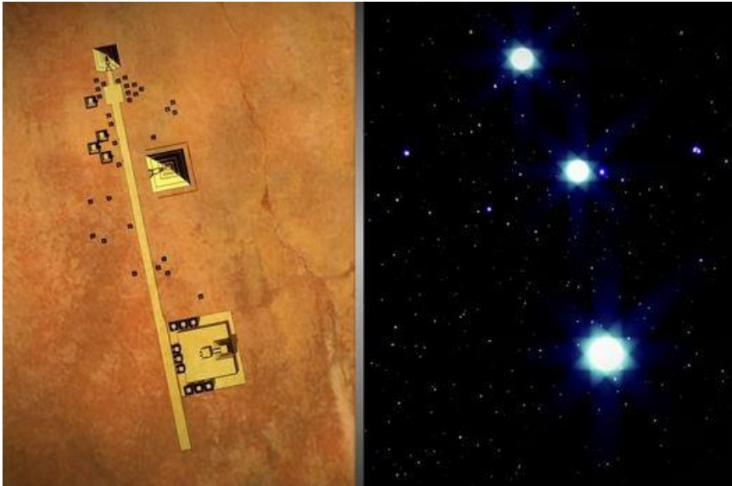

**Teotihuacan and Orion are perfectly aligned. Image credits:**

**History Channel**

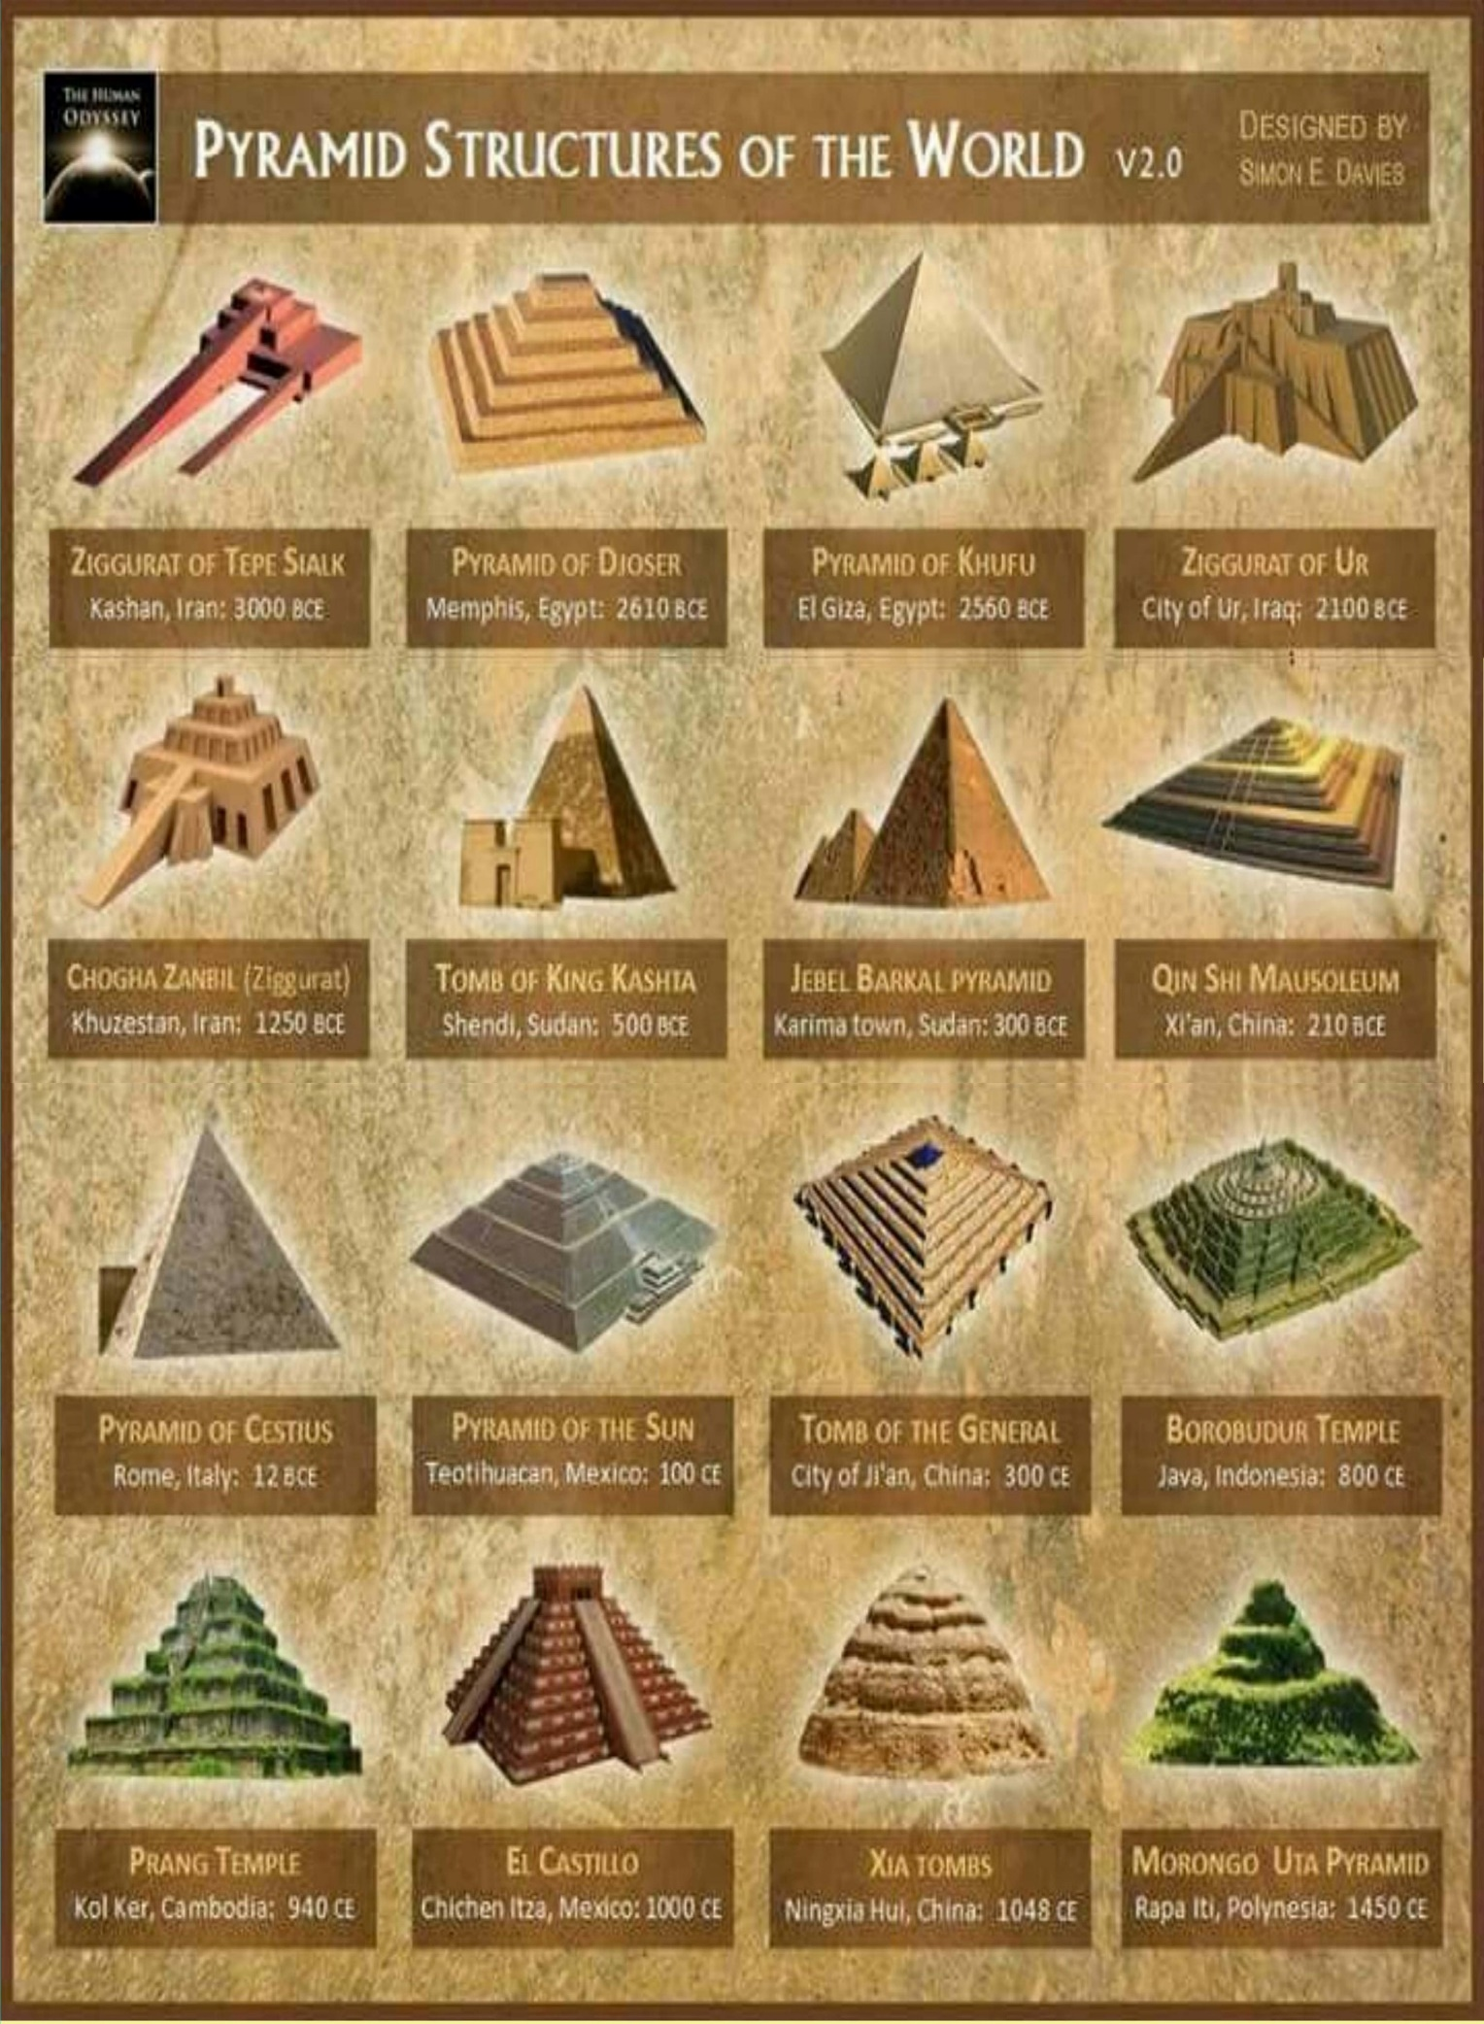

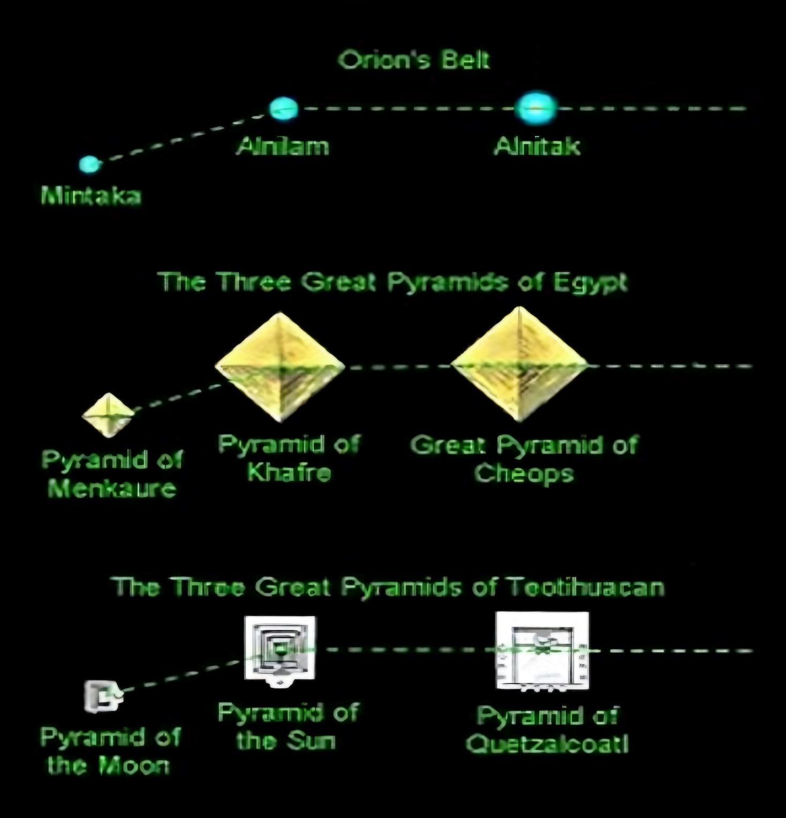

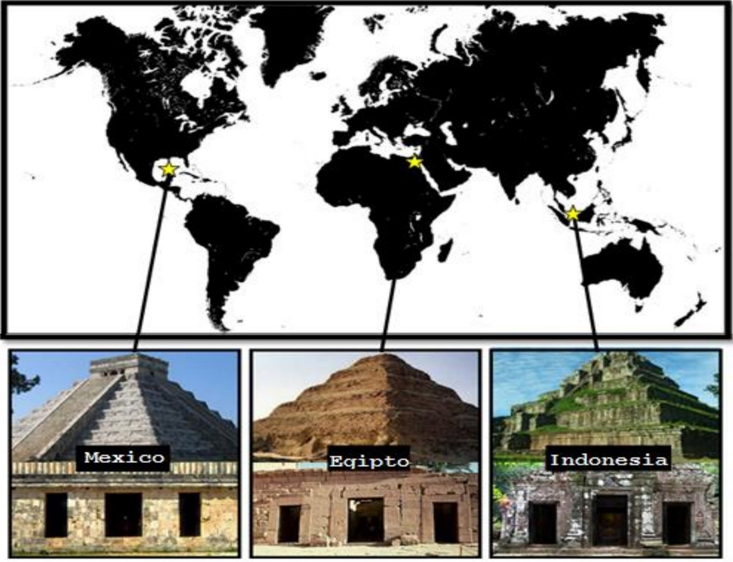

CHAPTER 8

Is there INTELLIGENT life on other planets?

It would seem that after everything we have discussed in previous chapters, this question would be more than answered, but we are going to try to answer it concretely by providing more precise information on the subject.

From a physical standpoint, based on statistics and probabilities, it would be truly impossible for there to be no life on other planets, since there are millions of stars and planetary systems (astronomers estimate that there could be **40 billion Earth-like planets in the Milky Way**).

The issue is that from a **biological perspective**, it seems even more improbable than probable that there is life on our planet, and not to mention in other places in the cosmos.

**What is necessary for life to exist?**

For life to emerge, the first thing you need to do is find a good location. It is preferable to be on the periphery of a galaxy. At the Centre of the galaxy, the stellar density is higher and the chances of a supernova being nearby are greater. The Sun is not only in the right place, but it is also lucky enough to be in a clear neighborhood, which minimizes the risk of gamma ray emissions.

Then you need a suitable star, one that does not expend its fuel too quickly, because life needs a lot of time to emerge and develop. It must also not be a very young star, because the composition of these is generally hydrogen and helium and other elements necessary for life are lacking. A star that is too small is not suitable either, because then the habitable zone is too close to the star, which causes the planets to be anchored by the star's gravity and not rotate around themselves, as happens to the Moon and the Earth. Thus, one side of the planet has temperatures of several hundred degrees, because it is always exposed to sunlight, and the other, which is never hit by the star's light, is freezing.

Just as it was important for the star to be well located within the galaxy, it is also important for the planet to be well located concerning the star, because if it is too close, the water vaporizes, but if it is too far away, it freezes.

The planet must be rocky, because if it is a gas planet, it is not suitable. The planet must also have a molten core to generate a magnetic field that protects it from cosmic radiation and the solar wind. This requires a certain mass.

It is estimated that Mars had liquid water and a moderate temperature for its first billion years. However, because it is small (about half the size of Earth), the heat quickly dissipated, the core solidified and stopped generating a magnetic field. Without this protection, the solar wind blew away most of the planet's atmosphere. A planet that is too large is also not suitable, because the atmospheric pressure would be too strong. Some astronomers estimate that the ideal mass would be in the range 0.2-10 times the mass of Earth.

**What if there are many planets that do fulfill some characteristics?**

As an example, we have the discovery of Gliese 581g in 2010.

According to astronomers, the planet Gliese 581g is located at a distance from its star that allows it to have an **optimal temperature** for liquid water to exist on its surface or at least at a shallow depth.

Among its characteristics, its temperature ranges from minus 31º to minus 12º Celsius, it has gravity, its orbital period is just over 36 days, its mass is between 3.1 and 4.3 Earth masses, and, in addition, the attraction of the star Gliese 581 means that it always has one side with light and another dark and cold one. Therefore, they point out that the most probable area to have life would be the one that is

closest to the limit between day and night.

Gliese 581g was the indication that astronomers, astrophysicists and researchers began to consider more seriously the idea that there are really many more planets with characteristics similar to Earth than was believed and that there may be more life in the universe than we can assimilate.

**But what about intelligent life?**

Life can form on planets similar to Earth, but intelligent life is another issue. Finding microorganisms may be fine, but what we really want to know is whether or not there are other beings like us or even more intelligent (or well, they may be less developed).

**Can the most intelligent beings be from Saturn?**

I didn't see the importance of touching on this subject when I was researching, but then I remembered something I read in the book "The Law of One" already mentioned, where Ra (extraterrestrial being who answers questions) commented that the Eighth Dimension beings are found on Saturn, in the area of ​​the rings that for us is the third density (density refers to the level of consciousness, powers or intelligence of a being or beings).

This will surely seem very crazy to you although nothing that we will see in the book will be sane, but if you consider yourself a little more pragmatic: The German philosopher **Immanuel Kant** pointed out that the intelligence of the extraterrestrials was proportional to their distance from the Sun. For that reason, there would be an enormous variation between the inhabitants of the different planets, from the "clumsy inhabitants of Mercury" to the people of the Sun. "**ingenious beings from Saturn**." Coincidence or truth?

As you may have noticed, thinking about intelligent life on other planets is difficult for the simple reason that at the biological level the only thing we can hold on to is what happened on Earth, that is, how intelligent life evolves here and particularly how we evolved.

The thing is that we don't even know how we evolved.

In history, it is still said that it happened with the monkey, and that may be relatively true but up to a certain point, since from the last Homo Neanderthaliensis to Homo Sapiens there was an immense evolutionary leap in a very short time.

If we ignore the evidence of intelligent extraterrestrial civilizations not recognized today but by past human civilizations, it seems that there was divine intervention, or at least, that beings more advanced than us intervened in Earth's history.

Before we close this chapter, let's resolve this last very common doubt:

**Why are retired people always the ones who tell their experiences at NASA?**

Edgar Mitchell, a former NASA astronaut who holds the record for the longest time working in open space, said in an interview that it is very difficult for NASA professionals, Air Force pilots, and anyone in the aerospace and military field to report a UFO, since if they do, they risk losing their credibility and their jobs. This is why many people wait until they retire to speak out.

In September 2006, the Atlantis Shuttle, during the STS-115 mission, delayed its return to Earth by 24 hours because a UFO came between the spacecraft and the Earth's atmosphere. During the mission, the crew also witnessed other UFOs flying nearby: 5 spheres and a tubular object.

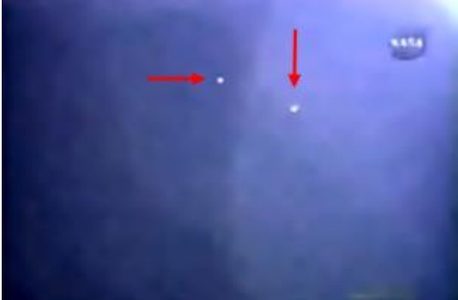

**Two of the five spheres seen on STS 115**

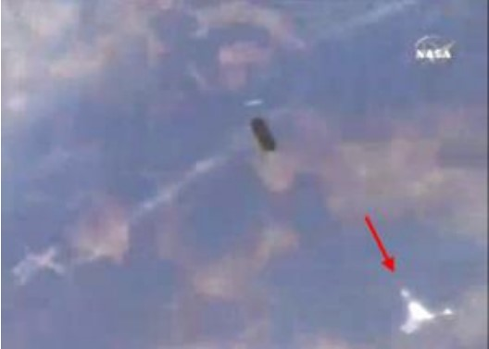

**Unidentified tubular object and one other object recorded by the STS 115 mission.**

When they finally arrived on Earth, astronaut Heidemarie Stefanyshyn-Piper wanted to tell the public what she had seen in a press conference broadcast live on FOX, CNN and NBC. But something strange happened: at the moment of making the revelation, she fainted. She stood up again and again, something strange happened to her and she fainted again.

This UFO experience that the shuttle crew had during that mission was never spoken of again. Were these fainting spells natural, caused by emotion? Or perhaps, are they some kind of neurological technology used by NASA to ensure that its astronauts do not reveal secret information in the middle of televised press conferences?

CHAPTER 9

What is time? Is time travel possible?

It is what governs our lives and we have not the slightest idea of ​​who created it or if it is anything at all.

But what exactly is it that we measure? Is time something that

physically exists or is it just in our heads?

At first, the answer seems quite obvious - of course time exists – it constantly unfolds around us and it is very difficult to imagine a universe without it.

If we ask ourselves the question of **what time is**, we would already be referring to the fact that time is something, and without first mentioning everything you are going to read in this chapter, I dare to tell you that time is not something, time does not even exist and is a simple creation of the human consciousness of each one of us.

“The divine illusion of time, which appears to us like a film, with moving images, changing, when there is only one frame: eternity.” –**Anonymous**

We must be 100% honest, the past is memories and the future is expectations of what we would like to happen or what someone can say will happen. The only certainty we have is now, the present moment. What is difficult to understand about this is that the present moment is eternal, since every moment in which we become aware of what is happening we would be living in the now, that is why time as such does not exist, what exists is the infinite succession of images that pass by without ever stopping in the now.

**But what about memories? When I am remembering something, it is something that has already happened, that is, in the past.**

When we remember something that happened to us in the past we remember it now, therefore those memories exist because your conscious mind can remember them at this moment.

To answer the other question things, get a little complicated, since asking ourselves about time travel covers either past time or future time. Therefore, what you read in the previous paragraph we must question.

**Is time only the present moment?**

Although the answer is still yes, the human mind still has the ability to remember those events that happened before what we are experiencing at this precise moment, and it also has the ability to create through imagination and visualization situations that have not yet occurred.

So… **time travel does exist.**

Albert Einstein (whom we will discuss later) has been one of the most prominent scientists who have focused on this topic, as he introduced very interesting theories. Over the years, many other scientists have continued to investigate over the years, and it was not until very recently that it was actually proven that time dilation (which Einstein talked about) is a completely real phenomenon.

Time dilation basically consists of time passing more slowly for a moving clock than for a static one. The force of gravity also affects the difference in the time that passes. Because gravity and speed are related, the more gravity and speed there is, the greater the difference in time. **Example**: Black holes.

But if what we want is to travel in time and not die on the way, we better stick with the option of increasing speed.

One of the options for this would be a wormhole, also known as the **Einstein-Rosen bridge**. Along with physicist Nathan Rosen, Einstein suggested the existence of wormholes in 1935, and although none have been discovered, many scientists have contributed their theories about how they might work.

One thing that has been proven through space programs is that the ticking sound of clocks on the International Space Station is heard slightly slower than that of clocks on Earth. Since the station is moving faster and is not affected by gravity, **time moves faster**. This is also why clocks on **Earth are not accurate** since the effect of time dilation means that time moves slower the closer one is to the Earth's surface.

A better example would be satellite GPS. The GPS chip in your cell phone works because 24 satellites around the planet triangulate your location based on the time it takes for information to travel to and from the device.

However, in building the system, scientists learned that the atomic clocks on the satellites walk a little faster since they are moving at 14,484 km/hr in orbit. To be more specific, they lose 8 microseconds a day. It seems imperceptible, but it is enough to make the location miss. For this very reason, GPS technology adjusts clocks to compensate for the effects of time dilation.

Because of this, many questions arise, and although they seem pretty crazy at first, the fact is that they are not at all.

If we had a spaceship that flew super-fast, time would pass faster for people on Earth. You could fly around the galaxy and return to Earth in the future.

Einstein's theories of time travel claim that it is **impossible to travel to the past**, but they are still theories. A future discovery may confirm or overturn them.

“When you look superficially, it appears that the present moment is one among many, many moments. Every day of your life seems to be made up of thousands of moments in which different things happen. But if you look deeper, isn't there always just one moment? Isn't life always "this moment"?”

–**Eckhart Tolle**, The Power of Now

CHAPTER 10

Why is there something instead of nothing?

When we ask ourselves why, we are conditioned that there must be a reason, and maybe the universe doesn't even have a purpose for being, so we better change the way for how; **How is there something instead of nothing? How does something come from nothing?**

To start with this, we have to consider the most popular theory to date: The Big Bang, although it can be highly questioned.

The Big Bang also had no reason to exist and even how it came about goes against all logical explanations, since this explosion supposedly occurred because there began to be more matter than antimatter.

On a mental level, we have to consider that we would not ask ourselves this question if we did not exist or were conscious and capable of thinking.

As far as we can say, on a biological level we are the only living beings that have reasoning, "we are intelligent."

If we did not exist, in our reality nothing would exist, but everything could also continue to exist since we are not the only living beings here; the issue is that other beings (as far as we know) do not ask themselves this type of questions.

Therefore, if we are capable of asking ourselves that is because there is something instead of nothing, but we are not yet capable of imagining and much less proving that nothing exists.

On a conscious level, we still do not understand that something can be produced from nothing, since apart from going against physics it also goes against our ability to think.

The strong point in this question is that whether it is demonstrable or not, whether it is credible or not, **the only reality we have is that everything came from nothing.**

Do you remember **Lavoisier's Law**? Energy is neither created nor destroyed, it is only transformed. The universe is energy, billions of particles at the quantum level compose it.

So?

This law would tell us that the universe has always existed because energy could not be created from nothing.

And according to **Taoist cosmogony**, before the creation of the manifested universe there was a state of total emptiness. In that primordial state, nothing moved. The relative concept of time had no application in that primordial state, since there was nothing to compare it with. Everything was a **vacuum**.

But the first thing we want to affirm is that it was created, that the universe exists and we do not know how.

At this point, when in reality we do not get anywhere, it seems that the most sensible thing is not to dwell on this question. We really cannot know why, much less how it was created.

There are very good theories formulated by the best scientists and researchers of all time, there are even laws, but from my point of view, although they seem to be close to the truth, they are very far from an absolute truth.

CHAPTER 11

My opinion on a historical account:

The Bible

For believers, the Bible is the word of God, as it is undoubtedly divinely inspired. It is an eminently spiritual book and talks about the history of humanity, its creation, its fall into sin and its salvation, and it explains how the creator God has related, relates and will relate to human beings. Likewise, the Bible explains the attributes and character of God.

**But the Bible is not the only religion there is.**

Rabbinics consider the Talmud as a source of doctrine, while the Karaites have defended the Tanakh as the only source of faith since the 8th century.

In previous chapters, we answered questions that can be used to question the existence or non-existence of God, but I will not focus on that, since in my opinion, with the material from the previous questions, each person can formulate his or her own answer about the existence or non-existence of something.

My opinion is specifically about the book The Bible, not about what is said there.

I must be honest with you, I have never read The Bible, I have only heard, seen, and read enough to understand its origin and its arguments.

I think that just like the Divine Comedy, The Bible is a literary story that lacks scientific foundations, but if there is one thing it does not

lack, it is faith in those who believe in what is said there. So, **could it be true?**

There is a phrase that I used to use a lot until I realized that it was not quite right:

“if many people think/do something they cannot be wrong.”

And the truth is that yes, they can.

Why do I believe this? Because the same thing happens with gossip or lies spread by word of mouth.

When we read something and then tell it, we run a very high risk of distorting the information because two factors influence it:

1. How well we are able to tell it and

2. How well the other person can understand us.

The Bible is a very old text that has passed through millions of mouths and ears, from generation to generation.

It has been written in 2,303 different languages. What can assure us that each book says the same thing without interference?

What can assure us that each person who reads it understands the same thing? And not to mention every person who has transcribed it.

I do not consider myself a believer or an atheist, I only question what is there and formulate my ideas. It is not about being credible or not, it is about what each one believes.

I am not at all against the Bible because I believe that it has helped

keep the world's population docile and submissive for thousands of years, which to a certain extent is good (I refer to the 10 commandments).

But beyond that, we can question it just as we question scientific laws and theories. The biggest mistake is to fall into an absolute truth, which does not allow you to see all the worlds that also exist.

You have to know how to accept uncertainties and investigate, not create comforting lies and defend them without any proof or support.

“Let us assume for a moment that he is right, and that the Bible is indeed the infallible word of the one true God. So, what do we do with the Koran, the Talmud, the Book of Mormon, the Vedas, the Avesta, and the Egyptian Book of the Dead? Are you not tempted to say that these texts are complex fictions created by real humans (or perhaps demons?) And how does the reader regard the divinity of Roman emperors such as Augustus and Claudius? The Roman Senate claimed to have the power to turn men into gods, and then expected the subjects of the empire to worship these gods. Was this not a fiction?” -Excerpt from the book “21 Lessons for the 21st Century”

CHAPTER 12

Is there a single supreme being?

This question seems complicated but it has a small detail, it uses the word “**single**”, so to try to answer it we must see if there are several supreme beings, and by refuting or affirming this we can easily answer this question.

What is history and even the time in which we live seems to indicate without a doubt the existence of many supreme beings in various cultures (we could call them Gods), so as a short answer would be

that no, there is not a single supreme being.

The question is to answer whether it exists or not.

We have already talked about existence in two chapters, so we only have to play with words to try to answer it, although as far as I see it, there is no logical, objective, or true answer to this question. To question the existence or non-existence of something superior is already unnecessary, because the answer escapes our logical and imaginative understanding, and now to question whether there is a single supreme being is more illogical and unimaginative.

We could stick with the tales of ancient civilizations, believe in any of them to have an answer or we cannot believe in any and have an answer as well.

If there is something that is extremely proven without a doubt, it is that everything is energy. The complicated thing is that if we resort to the existence of a Supreme Being, Omnipresent and Omnipotent, **how do we explain the existence of this being?**

Perhaps, if everything is energy, consequently that being would also be energy, and energy cannot be created or destroyed, only transformed. Which brings us to the chapter on time where only the eternal present exists.

**Is a supreme being or god infinite energy without beginning or end?**

Probably all organic beings that have ever lived on this earth have

descended from some single primordial form, which was first given life... This view of the origin of life has its grandeur... for as long as this planet has been going around and round according to the fixed law of gravity, from so simple a beginning there have been and are evolving endless forms, the most beautiful and the most wonderful.

-CHARLES DARWIN the Origin of Species, 1859

CHAPTER 13

Everything is made in a perfect way:

Fate or chance?

I decided to use the word “**everything**” to refer literally to absolutely everything we know; basically, referring to the universe and our body.

We previously said that the conditions for the Earth to harbor life were very scarce and that it was one of the reasons why biologists doubted the existence of life elsewhere.

It is true, we also said that probabilistically there are millions of opportunities for this to happen, and that even astrologically planets similar to ours have already been found. Even so, whether it is our planet or another that resembles it, there are things that seem to be made in a perfect way so that other events occur as a result that are also perfect.

It is as if perfection reigns in the immensity of chaos, paradoxically.

It is for these reasons that religious believers always cling to their creator gods, because it seems like a fairy tale where magic does exist, since there is no explanation beyond the known one to understand these issues.

We have nowhere to start, so reaching an answer without a starting point is the most complicated thing you can think of doing.

We all have beliefs, sometimes individualistic and many others with a group of people, but they are beliefs.

If the entire perfect creation of the universe and of the human being was thanks to destiny, we would assume that everything is already destined to happen, that everything happens just like that; On the other hand, if we choose to believe in coincidences, at least we would be giving the universe room to be what it is, a chaos where everything seems to happen in a random, casual way.

I would like to add the term causality since it helps us to put both things together.

It is true that everything seems to happen in a random way, although it also seems that there is a destiny and everything happens because it must be that way. But everything also has a cause for being, and consequently produces an effect: **causality**.

**A simple wordplay, far from the absolute truth.**

Perhaps not even the answer can be described with the words we use today. The amazing perfection in chaos.

The human body is a true machine, which is normally calibrated to

perfection for the preservation of “homeostasis” or “balance” through the joint work of numerous systems: a nervous system, with the brain and spinal cord as its main parts, which send signals to other body systems to control its functioning; a cardiac system, with the heart and blood vessels as the main players, which are responsible for transporting blood with oxygen and nutrients to all the cells of the body, and for carrying waste from these cells to the lungs; an endocrine system, which secretes hormones from different glands so that they act on specific target cells that will cause a desired effect in the body. The complex mechanisms by which these and other systems (such as the digestive, respiratory and immune systems) act and allow a body to maintain its state of health are thanks at the same time to the teamwork exercised by the basic functional unit of our body: the cell; Although its size is small, its quantity is numerous, consisting of 100 million gears working together so that the different systems that make up this machine that is the body work harmoniously.

**The golden number or golden ratio**

This number is also known as the divine number. It is found in the creation of absolutely everything we know, since it is not only found in geometric figures but also in all of nature.

I also introduce it in this chapter so that you can see even more how perfect everything seems to be created.

**1- In the human body**. It turns out that the ratio between the height of a man and the distance from the navel to the tip of the hand is the golden ratio. The most striking one may be the one related to the navel: if you divide the total height of a man by the distance from the navel to the feet you get the golden number. In dentistry research, it has been shown that the teeth grow according to the golden ratio. In our hands, the phalanges are in golden sequence 6.

**2- In the plastic arts.** It appeared in the 5th century BC in Athens, the Greeks knew it and used it in architectural and sculptural designs. One of the most famous constructions in which it has been used is the **Parthenon**.

We also find the proportions of the golden rectangle and its sections in **the UN Building in New York**.

**3- In music**. In several **Mozart piano sonatas**, the ratio between the development of the theme and its introduction is as close as possible to the golden ratio. Although **Beethoven** is not known to have been aware of this, in his Fifth Symphony he distributes the theme following the golden section. In instruments such as the **piano**, since it is made up of seven octaves arranged in ascending order from **low to high**. Thus, the first six numbers of the **Fibonacci sequenc**e, very similar to the golden ratio, appear in a piano octave, which consists of 13 keys: 8 white keys and 5 black keys, in groups of 2 and 3.

**4- In mathematics**. The golden number or golden proportion is present in all regular or semi-regular **geometric objects** in which there is **pentagonal symmetry**, which are **pentagons** or in which the square root of five appears in some way. It is related to the **Platonic solids**, in particular the **icosahedron** and the **dodecahedron**, whose dimensions are given in terms of the golden number.

**5- In nature**. There are many elements related to the golden section or the **Fibonacci sequence** that have a great similarity. The arrangement of the **petals of flowers**, the distribution of **leaves on a stem**.

The relationship between the veins of **the leaves of trees**. The relationship between **the thickness of the main branches** and **the trunk,** or between **the main branches and the secondary ones**.

The number of spirals in a **pine cone**. These numbers are elements of the Fibonacci sequence and the quotient of two consecutive elements tends to the golden ratio. In the number of petals in flowers, there are, for example, flowers with 3, 5, and 8 petals and also with 13, 21, 34, 55, 89, and 144. It is in the DNA and we can discover it in countless other examples.

It seems totally crazy because it is totally true and proven, everything points to what I mentioned in previous paragraphs, a complete perfection in chaos.

For whom was this perfect and wonderful world created? Can we still say that everything is the product of a mere coincidence? Are we sure that everything around us is not perfect?

CHAPTER 14

What are dimensions, who created them, and how many of them exist?

From the spatial side, dimensions are the metrics that physicists use to describe reality. For example: humans are in the third dimension because they are able to observe width, length, and depth.

But Albert Einstein in 1905 introduced a new theory: spatial relativity, introducing the fourth dimension. Time is essential to locate an object in space and at a given time, complementing the other three dimensions that we know.

This would explain the universe as we know it (humans), since we can see everything in the third dimension and even theoretically we are in the fourth dimension.

As we discussed in Chapter 9, time is a continuous succession of reality, we see everything passing by as a “straight line” which would be the form of representation that the fourth dimension would have.

The subject of dimensions is very extensive but since we are going to question everything it is not necessary to go into all the theories that exist, even so, we must take them into account, since today they are the closest to an answer.

We have one of the most popular theories to go a little deeper into the dimensions: **string theory**. This theory aims to unify two main theories that describe how the universe works: general relativity (which applies to very large objects) and quantum mechanics (which applies to small ones).

According to string theory there are seven more dimensions apart from the four mentioned, giving a total of eleven dimensions. Scientists realized that in a four-dimensional universe this theory would not be possible, but once they modified the math to include ten dimensions (eleven over time) the equations worked.

**The fifth dimension** according to string theory tells us that it is a world slightly different from our own, from which we could evaluate similarities and differences. Basically, it is about “alternate worlds” where, for example, changing just one decision in our life, everything would be different.

**The sixth dimension** is the plane of all possible worlds with the same initial conditions and is explained as follows: in this plane it is possible to travel between different realities of the fifth dimension without needing to go to the past, basically because there is no past, present or future; we are all in all of them and we can go to any of them whenever we want and in different realities. For example: How could we go from one timeline to another, without having to travel great distances? Exactly as it happened in the transition from two to three dimensions: folding the universe, and for this we need the sixth dimension.

**The seventh dimension** is a plane of all possible worlds with different initial conditions, something similar to the sixth dimension, but in this case the beginning is different in each plane.

**In the eighth dimension** there are different universes compressed into one, which is necessary for travel in the seventh dimension. These universes originated in a different way from ours and the matter is different from what we know.

**In the ninth dimension** all worlds are possible, starting with all possible initial conditions and physical laws, which are completely different from what we know today.

**In the tenth dimension** the possibilities are infinite and in graphic representation, it would simply be a point, like the beginning, but to obtain a different point and draw a line and thus continue with the process, we need to imagine other possible infinities and this can no longer be done. We have considered all the possible beginnings of the universe, and all the possible evolutions of the universe, it cannot be continued.

Well, these would be the dimensions according to string theory, and they are the spatial dimensions, but there is another side of the coin:

the dimensions of our consciousness.

**The 7 spiritual dimensions:**

The dimensions in these levels are governed by the levels of energetic vibration and their respective levels of understanding that

every living being progressively acquires in life in which its life experience gives it a knowledge that makes its consciousness expand. They are levels of understanding, knowledge and energetic liberation.

**FIRST DIMENSION**

The first spiritual dimension is the creative one, since it is, at a quantum level, where energy is converted into matter. In this dimension everything we know today is formed, life and the cosmos in general.

This dimension is the matrix of existence, and is therefore connected to the seventh dimension in a cyclical way.

**SECOND DIMENSION**

The second level is the elemental dimension, where basic and purely instinctive life is formed in this state.

This dimension is where most animals and plants exist.

**THIRD DIMENSION**

The third dimension is the physical world. This is where the human being lives. In this stage of the seven dimensions, we understand ourselves as rational and individual beings capable of having our own identity and perceptions.

This dimension is considered the most fundamental since it is where we learn self-awareness of the whole and live our personal experiences.

**FOURTH DIMENSION**

This is the last dimension where we continue to be physical beings. In this dimension it is said that we manage to perceive beyond the world that we see and that surrounds us in an obvious way. It is known as the astral plane.

We understand feelings, emotions and dreams. Depending on the intensity with which they are perceived, our development will be leaning more towards the third or first dimension. In it, we also understand that our actions affect the whole that we inhabit.

When a person dies, his or her consciousness moves to the fourth dimension, crossing “a light that is found at the end of a tunnel.” This has been described by millions of people who have had close encounters with death as we discussed in chapter five.

In this dimension is the so-called "dream world" or world of dreams and is known as the passage from the fourth to the fifth dimension. It is the frequency in which we begin to become aware that we are not only a physical body, and we begin to perceive beyond the physical senses.

**FIFTH DIMENSION**

This state of consciousness is eternity. It is said that this is where the ascended masters and spiritual guides are alone. It is the dimension of energy where we can merge with beings that vibrate at our frequency to form a being of higher dimensions.

It is the dimension where we remember who we are, and awaken our internal wisdom.

We go from being mortal bodies to being infinite souls thanks to the high level of collective wisdom that we have developed. In this state, we will be able to choose to become the guide of other souls from the previous dimensions.

**SIXTH DIMENSION**

This is the dimension where we take responsibility for the Whole and are the Whole.

In the sixth dimension, the state of consciousness will allow us to conceive the cells of the first three dimensions.

It is also called the dimension of enlightenment, known by mystics as the true reality, Buddhists call it "nirvana."

**SEVENTH DIMENSION**

At this level of vibration, energy takes precedence over the physical, that is, the spiritual body is superimposed on the physical body. It is the frequency of total integration of the being. We can only ascend to this state when we are pure love and our energy vibrates in this way.

In this dimension there are no forms, only colors and sounds. However, and although at this level we only know the one that is formed with others, we are also capable of being aware of the states that we go through.

Each new level of consciousness and each higher dimension will be revealed either collectively or individually as the being evolves. Although I have named these seven spiritual dimensions, it is said that there are more, even 13, but our vast human understanding allows us to reach the seventh.

These dimensions exist in the here and now, although not all of us can perceive each one of them.

As you can see, the spatial dimensions of physics and the spiritual dimensions are not so different, since at the quantum level they have a similar beginning.

**What if the spatial dimensions are a confirmation of the spiritual dimensions?**

Both speak to us of a beginning with a cyclical end, and both describe that it is the energy that becomes matter and is what has happened since… what do we have consciousness?

Because that's the thing. All theories are created by humans, with the scientific method yes, but by humans.

And these things are achieved thanks to a certain level of consciousness that allows us to reason, think, and deduce according to what we observe.

But if humans did not exist? How would we know about dimensions? Who assures us that they exist? How would we create them?

It's not that we go through life inventing things, but maybe if we did not have consciousness nothing would exist.

So spiritual dimensions are not crazy at all, and spatial dimensions seem to confirm what already exists according to our consciousness, even if they are theories.

CHAPTER 15

Why is a part of our brain known as "reptilian"?

Are we reptilians?

That a part of the brain is known as "**reptilian**" is because of the neuroscientist MacLean, who in 1952 divided the human brain into three parts: the reptilian complex, the limbic system and the **neocortex**.

According to McLean, the reptilian complex, being the first to appear, would be the structure that carries out the most basic and most important functions to survive in the here and now, it is like the part that works by instinct and helps us survive, they are like impulses.

The reptilian brain, being the most primitive part is also related to the addiction to power, where the only thing that matters is oneself. Do you remember the ego?

Another important detail is that we share this same brain with other mammals and reptiles.

We are not going to go into the other two parts because it is not relevant. I want you to stick with this for now. But if you have ever heard that we are “reptiles” it may not be as far-fetched as you thought.

**Where did the Reptilians come from and what role do they play?**

The reptilians “came out” in theory, where supposedly their role is to govern the Earth since they are among the high command, something that would not be very crazy if we know that the reptilian brain that we all have is what it most craves: **power**.

There are several theories surrounding this topic, but the most popular and well-known says that the reptilians are aliens who come from the Alpha Draconis solar system, and those who are on

our planet lives in underground tunnels.

As much as we talk about theories, we must keep history in mind: ancient civilizations point to a reptilian being as an evil deity, the Aztecs with Quetzalcoatl, in Athens there is Cecrops, in India the

Naga, in Africa the Chitauris, in Egypt there would be Sobek and others believe that they were the ancient astronauts; extraterrestrials who came down from the sky, the famous Anunnaki.

It is said that Sumeria could be the possible origin of the reptilians, this city is known as the cradle of all civilizations. According to the Sumerians (as well as the Egyptians, Mayans and Aztecs) their gods came down to earth from heaven, long before the arrival of humanity. They called them “Annunaki” and in the Bible they also appear under the name Nephilim, although some erroneous translations of the term call them “**giants**” when in reality it is “**those who came down from heaven to earth**”.

Humans saw these beings as gods, since they were intelligent, possessed many technologies and knowledge and had great longevity, although they were mortal.

It is curious how today we are so locked in a bubble that at the first

theory it is already conspiratorial, and the person who defends it is crazy. I totally agree that a civilization can invent gods, but you have to start to doubt when there is not one civilization, but several thousands of kilometers away that tell similar stories. And to add to this, they carve giant sculptures on stone and walls honoring these beings that came down from heaven.

In the Hathor temple in Dendera, Egypt, human beings of reptilian nature along with pharaohs can be found on the walls. The Hopi Indians in North America tell that an alien race BAK'TI genetically manipulated animals and created the human being.

Oral traditions teach that the extraterrestrial race BAK'TI, in the end, lost control over the human race in favor of another race that were depraved reptiles. The Hopi tribe calls the race of reptilians the Sheti, or “serpent brothers”, who live underground.

The Cherokee tribe and other American tribes also refer to the reptilian people or other races of reptilians. In ancient Mexico there was a king named Quetzalcoatl, meaning serpent-bird. He was the star god who brought civilization and knowledge of the cosmos to the people of Central America.

Texts from the Yucatan known as the “chilaam balaam” say that the first inhabitants of the region were known as the “people of Chanesh,” meaning the “people of the serpent.” They were ruled by a king named “Itznamnam,” meaning “lizard,” who is depicted as half human and half serpent. 5,000 years ago, the Olmecs erected statues of their gods on the ground. protective spirals of gigantic serpents.

In ancient times, the role they played was that of Gods, at present, nothing is known about them except speculations and “conspiracy” theories that are not relevant to comment on, not because they are true or false, but because the question in this case has already been

answered.

Before closing this chapter, I want to tell you about the most surprising case of “reptilian human” that I have “seen” so far. It is another of Nacho Rojo’s great investigations.

There is a Russian organization called “Allatra” where in videos that they upload to YouTube -with very good quality by the way- they tell and transmit their thoughts about humanity, the world and the universe in general.

In his videos, there are almost always the same three people talking about a topic, two women and a man, and it was in one of these videos that something never expected happened: one of these women rolled her eyes for a few milliseconds, where reptilian eyes were observed.

After that first video, there are even others where she does it again and they themselves talk about the reptilian topic, without affirming anything, but implying everything.

This is very beautiful to see since they do not hide anything and show this anomaly, if you could say so, in a very natural way and worthy of observation.

Luckily, this case is being well investigated by Nacho, however, there are also other famous people who have had this sudden “transformation” in their eyes, very similar to Allatra’s case, as is the case of Miley Cyrus (I invite the reader to look for videos on YouTube and formulate their opinion).

CHAPTER 16

Why are there other types of races within the human race?

We have already talked about the Bible, but since it is the most popular book on the genesis of humanity, I have to ask the question:

How is it possible that from Adam and Eve, two beings with a “pure race” can have children with such different characteristics?

We know very well that there are people with white, dark, yellow skin; striated or larger eyes.

In the books of Kabbalah and also in the Talmud, it is said that the climate makes a person have certain characteristics; and in the Sanhedrin treatise they tell us that the “Eternal” divided people by languages ​​and lands and that people also changed their characteristics abruptly.

Scientists, on the other hand, do not agree on how many and what racial subspecies there are, and this is because humans who could have been pure became extinct thousands of years ago in the Paleolithic era, although in southern Africa there are still some pure aborigines.

Depending on where we are in the world, we will have more genetic contribution from one race than from another, which is also why the differences are still very deep-rooted.

And the simplest explanation of why we have different skin colors is due to melanin, which is responsible for giving us that lighter or darker pigment. The darker color is an evolutionary response of adaptation to the environment over thousands of years: where there is more solar radiation, people will have darker skin because to protect their organs they will produce more melanin.

That is why it is said that those with whiter skin are “bleached skin.”

The closest thing we have is this:



Looking at this image, the following question comes to mind: why is each race so different? And not only in terms of physical features, but also in terms of physical conditions and mental intelligence, as well as cultural behaviors (not to mention language).

How could this be possible? Is there any way to explain this without resorting to the answer that we all come from a single creator? But if we are all so different, how can we all come from the same place?

**DNA**

We all share 99% of the genetic material (Indians, blacks, whites and mestizos) the genes are the same. The differences are in that 1%.

60,000 years ago, just 2,000 generations ago, a small group of African humans went out in search of new lands and gave rise to the great physical and cultural diversity that has colonized the planet today. This was due to a sudden change in the climate in the Horn of Africa, according to paleoclimatic research, which says the climate changed from a humid phase called the "Green Sahara" to drier conditions than today.

The clues that this was the case are found in DNA, and this is the path taken by the American researcher Spencer Wells.

How did we migrate and diversify? Genetics tells us that we come from humans who lived in East Africa 60,000 years ago and migrated to Asia along the coast until they reached Australia 50,000 years ago. Another wave of migration, from which most Africans also come, traveled 45,000 years ago to the Middle East and Central Asia, and from there some went to Europe (about 35,000 years ago) and others to Siberia (20,000 years ago), from where they crossed to America.

**Do we all come from the same place?**

The nice thing about this chapter is that we can connect it a lot with the previous one, since if I answer this question quickly it would be yes, we all come from the same place, and even we come from reptiles... according to Charles Darwin's evolutionary theory.

In the evolutionary chain of species until reaching Homo Sapiens millions of years have passed and there are many species that preceded us. The last species and the origin of what we are today comes from 286 million years ago (the dinosaurs) specifically from the Collitosaurs (reptile).

What if I told you that what I just told you is wrong? We can still go back a little further...

It seems that if we go back to 530 million years ago, where we really come from is from a fish (**Haikou ichthys**, the first vertebrate fish).

Our body is nothing more than the evolution of the first fish that were able to leave the water and set foot on land.

Do you think we have nothing to do with fish?

**Why do our fingers wrinkle when we spend a long time in the water?**

This is an automatic reaction of the nervous system. This is because it is easier to grab wet objects with wrinkled fingers, it is one of the characteristics of human evolution. The ancestor of current human beings was an aquatic or semi-aquatic primate, already bipedal and with hardly any hair.

In our beginnings, we all started as a life form in a hydrothermal vent under water. We were a very simple organism called "Luca" as scientists call it.

Our bodies are the result of an evolution of 4.6 billion years. And although it seems that we have been here for a long time, it was only 3 million years ago that the first primates became aware of their existence and place in the world.

It seems that after knowing this everything is resolved, that we are who we are today on our own, without divine or extraterrestrial interruption.

This evolutionary period may have been like this for millions of years, but it may have been interrupted in later years. close, is that the evolutionary leap that humanity has achieved does not fit with the records of evolution as they have been given.

**Where do we come from then?**

Microorganisms, fish, reptiles, monkeys, from Africa, it seems that the problem is resolved in that order.

Although Charles Darwin may be right and the biological evolutionary process of man has been given through the species, it seems that something still resonates with us.

Many are those who believe that we come from the stars, that we are simply energy, and if we think about it well, they are not wrong either.

We have already said that everything is **energy**, we are all composed of it. At the quantum level, everything that exists is the same. We are one.

So, to answer the question where do we come from? We would have to be more specific and analyze in detail each year that has passed since the existence of the planet Earth, which is quite complicated since there are billions of them. The most logical thing we have are theories, which is that to have an absolute truth we would need to travel to the past and live those years.

CHAPTER 17

Who dominates the human race?

Let's think about it, nowadays it is not that it is the most difficult thing in the world to control all humans, and the question itself already affirms that we are controlled because that is an obvious fact, we only have to know who are those who are behind everything.

Over the years many things have been said, hundreds of theories have been formulated which link many presidents and world leaders such as Barack Obama, Queen Elizabeth II and many other influential celebrities to be those who are controlled by "the elite" and through them exercising manipulation.

**But who are those of "the elite"?**

Specifically, we do not know who they are, but there is enough data that together will give us an answer.

**Reptilians control the world**

We cannot ignore the reptilian theme, since as we discussed in its respective chapter, for many the “Elite” is reptilian and these extraterrestrial beings are those who control absolutely everything,

specifically, the high commands who are the ones who then directly influence the world population.

As you continue reading this chapter you will realize who controls the world and how they do it.

For the moment we are not going to discard the reptilian thing, only that at the end we will see a more in-depth answer on the subject.

**Money, the capitalist system and the richest and most powerful in the world.**

We all need money and this is the chain that binds us, but capitalism and consumerism took us to the extreme side years ago.

I am not a person who is against this system, not at all, I enjoy it, but in order to enjoy it you have to wake up.

The thing is that most of the population is asleep: absurd purchases, debts up to their necks, junk food, excess entertainment and little knowledge.

There are many ways to wake up and each one will have their own, maybe it happened to you with this book, when you realized all the things that exist, existed and will exist that no one had ever told you, that is a way to wake up, to be able to see the other side of the coin.

Others, instead of waking up, may be overwhelmed by so much information and so few conclusions and prefer to ignore and disregard everything they read here.

To wake up we just have to become aware, it is not about believing or not, we can believe things all the time, that is very easy. The point is to discover ourselves, to ask ourselves things, really deep questions.

In this case this book is inundated with generic questions that then

lead into smaller but complementary ones, all of this with the aim of going deeper and trying to “**get**” to something, even if we don’t need to get anywhere.

Capitalism (beyond what is said about this) has managed to keep the entire world population docile, submissive and well controlled.

All this through advertisements where new clothes, technological devices, accessories, cars, etc. are constantly emerging, where spending is encouraged and people end up getting into debt buying things that many times they didn’t even want to buy or know they don’t need, with the sole aim –let’s be honest- of pretending.

It's that easy, and if what I just said shocked you, you know where you have a problem.

As easy as it is, it's a little sad. The capitalist system is fine, being rich is fine, having lots of money and power is also fine (if your goal is to bring about positive change), but what is a real shame is how people go all out for this, forgetting that the only thing they really have is the present moment, which passes so quickly that it seems they don't even have time to live it.

Money is unlimited. Since it stopped being backed by gold a couple of decades ago, there is no longer a limit and it is printed in abundant quantities every day, which is why economic expansion is becoming more and more brutal, since as millionaires have more, they can do more.

There are many people who are making a positive change and helping the planet, but even though the richest are a small percentage of the population, there are many people who have a lot of money and contacts, so there are people from both sides of the road.

People are usually guided by Forbes magazine (specialized in the world of business and finance) which publishes the Forbes list every year, placing people in order - depending on the amount of money they have - own- the richest people in the world.

By this point in the book we have become accustomed to looking at the other side of the coin, so I must tell you that there is something that we must take into account with this magazine.

Even though it places the wealthiest people on the planet, the millionaires have the possibility if they so wish not to appear on it, therefore simply by looking at this list we cannot conclude anything.

To give you an example, it is known that **Queen Elizabeth II** is the queen of 32 countries and it is estimated that her wealth reaches $33 trillion dollars. She controls the Uranium of the world and owns 1/6 of the solid Earth, but she is not on this list.

**The three most popular dynasties that control the world: The Rothschilds, the Rockefellers and the Bush Family.**

To get into the subject, we have to know that the Bush family is estimated to have a fortune of 300 billion dollars based mainly on oil business since before the Second World War.

In the words of George H.W. Bush (former president of the United States between 1989 – 1993): “We have before us the greatest opportunity to forge ourselves and forge for future generations a new world order, a world that is governed by law, and not by the law of the jungle, which governs the conduct of nations. When we get it and we will do it? We have an opportunity for this new world order, an order in which a reliable United Nations Organization can develop to maintain peace and fulfill the promises and vision of the founders of the UN”

The next family is the Rothschilds. It is estimated that they have 500 companies under their control with a declared fortune of 500 billion dollars, much of which they have obtained thanks to great speculations in times of crisis. This family has controlled the world through the global economy, mainly through the economic and financial systems.

Finally, the Rockefeller family with a fortune of 750 billion dollars and some 600 companies.

Something that was discovered a few years ago that apparently was a well-kept secret is that since December 23, 1913, the Private Bank of the Federal Reserve (FED) took over the USA. The FED has 12 regional banks throughout the United States.

**What is curious about the Federal Reserve?**

• It is not Federal (it is not a governmental institution), nor is it a Reserve (it does not maintain any reserves by law).

• It is not a central bank, it is a private bank.

• Its owners are not all Americans (the **Rothschilds** are from London and Berlin; Lazard from Paris; Israel Moses Seif from Italy; the Kuhn, Loeb and Warburg from Germany) and the Lehman, Goldman, Sachs and **Rockefeller** families from New York.

• It issues dollars at will.

• The American people are indebted to the FED by a stratospheric amount.

As you can see, the Rothschild and Rockefeller families as well as other large multimillionaire families are the owners of the FED.

Now that you know a little about this “Federal Reserve”, it is time for you to look at the next image.

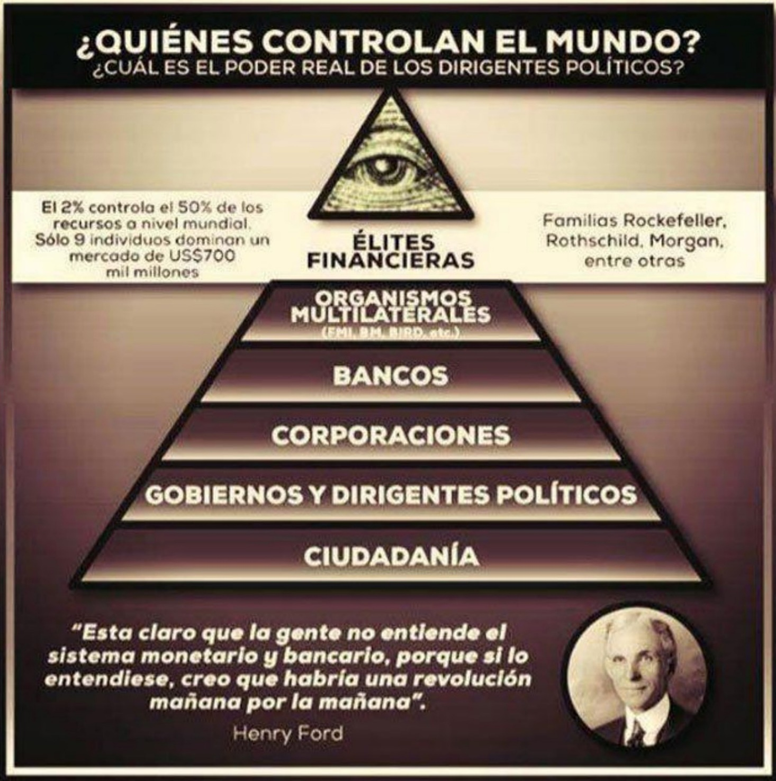

**To find out who controls the world, you have to follow the money ladder.**

Let's describe each link in parts:

**At the first level is the citizens, that is, all of us.**

The reality is that only a very small percentage of the world's population has all the wealth in the world, and the remaining percentage (let's say 99%) is middle and lower class.

At this level of the pyramid are the small and medium-sized business owners, the common workers and the families. The money

earned here is largely destined for taxes.

**At the second level are the Governments.**

Although one might think that they are the ones who "**rule**" the world, we are still very far from the true throne. This is the level where it is mistakenly believed that they control the world.

Governments, like any other institution, need a means to finance themselves. Political parties need to get money to support their campaigns, they get this through funding from large corporations that are at level 3. Once the political party wins, the government can enter into negotiations with the large banks or central banks (at level 4 and 5) to get funds and carry out their state projects.

**Level 3: This is where the large corporations are.**

We all need food, health, goods, energy, water, entertainment, gasoline, etc. and for this, there are these large corporations, creating all the goods we need.

But… what happens when these corporations become very powerful?

There is a term that is used to describe corporations that create large

monopolies and it is: Corporatocracy. Thanks to the huge fortunes that these companies have managed to amass, they have a very high purchasing power and are able to finance the political party they prefer. For this reason, they are above governments and it is for this reason that it is believed that giants of the oil, mining or technology industries are the ones that control the world at will. This is where we all get confused and think that these industries are to blame, but everything comes from much higher up. The reality is that everything is absolutely controlled to measure, so even though we may think that we are free, we are far from being so, because even many of the decisions you have made, even if they are of your own free will, are highly influenced by what they want you to see (algorithms that increasingly know your tastes more than you do). From food (toxins, pesticides, toxic minerals in food and water)

to education (traditional system so that you

never question anything and work for someone else because you

have no other choice).

But who finances them? Let's look at level 4.

**Level 4: National Banks.**

This is probably not a secret to you, but national banks are in charge of granting low interest rates to these corporations and obviously, (although in small ways) to the government.

The problem is that banks create money out of nothing. When they grant a loan, all they do is place the amount of the loan in bank accounts and from there, they start charging interest on an amount that never existed. This is possible thanks to the fractional reserve system that was invented a few years ago, and clearly, there is no need to change it.

**At level 5 are the Central Banks.**

What family do we have at this level? The Rothschilds, whose banks are private, not public.

A peculiarity is that there are very few countries that do not have these Central Banks (China, Venezuela, Syria, North Korea, etc.) and it also happens that these countries have a left-wing government or dictatorship.

**What can we say about this?**

Let's assume that for some reason these countries do not want to have banks from this family, it is also a great coincidence that these countries are always at war with the

US.

**The Sixth Level**: World Bank and International Monetary Fund

These institutions are the borrowers of the world. Their function is to lend money to countries to rescue their economy or make them grow. The World Bank specializes mainly in giving loans to developing countries at zero or very low interest rates. And who are the owners of these institutions? You already know, the Rothschilds are the majority shareholders of the IMF and the whole owners of the World Bank.

**Seventh Level**: Central Bank of Central Banks

Central banks are in charge of assisting and regulating the financial actions of national banks. These have a lot of power, but not as much as the Bank for International Settlements.

This bank serves as the central bank for all the central banks of the countries that are associated with it. Its main decision-making committee is made up of 18 members, who are central bankers. These bankers have the power to control monetary policy, manage the supply of money to national economies, set interest rates, and thus decide the value of our savings and investments. Basically, they have the power to decide whether a country grows or not.

**Eighth level**: Elite bankers

At the beginning of this post, I told you that “he who has the money, has the power.” So, the owners of the most powerful institution, capable of providing money to the central banks of countries and banks capable of lending money to entire nations, will be the owners of the world.

Among the most powerful bankers we have: the **Rothschild** family, the **Rockefeller** family, the **Morgan** family, the **Du Pont** family, the **Bush** family, etc.

I hope you remember the three surnames that I highlighted in bold.

At this point in the pyramid we already know that the elite bankers are the ones who rule the world, but it is time to start asking ourselves: What is the goal? Why do they want to have this control? Is this plan to control humanity directed by human beings like all of us? Could it be that those who have the last word on everything that must be done are extraterrestrial beings?

As I mentioned earlier, the reptilian theme continues to play an interesting role in this matter. I don't have much more to tell you on this subject, but there is something that fits us like a glove to conclude it.

It is about an interview that Karen Hudes had 5 years ago. This lady is a former Executive of the World Bank, and in the interview, she revealed something extremely strong:

“Because the one that is in the very core pulling the strings is a different species. It is not the human race. They are called “Homo Capensis”. They have been on Earth alongside humanity, since before this ice age”

So that the reader knows: in Peru, specifically in the small city of Paracas, the archaeologist Julio Tello made an amazing discovery in 1928, where he found a cemetery full of graves of beings with elongated skulls. In total, 300 skulls were found, dating them to about 3,000 years old. Subsequent scientific analysis by geneticist Brien Foerster determined that they had DNA with mutations that are foreign to any human being and that do not cause cranial deformation, presenting only one parietal plate. This type of non-human race is known as Homo Capensis.

In one part of the interview, Karen also said:

**“You have to think about what kind of motive human beings can have to be traitors to their own species.”**

Could it be that everything, from the capitalist system to NASA’s cover-ups, is directed by this non-human, apparently reptilian race?

If this doesn’t seem shocking to you yet, just wait for the last topic we will discuss in the book. Answering the last question posed, it seems that everything points to the fact that we are controlled not only by humans like us but by something superior to them even.

**The secret plan of the Illuminati in letters**

Surely you have heard the word **Illuminati** (from the Latin illuminated), but we are going to see where all this mystery comes from to understand it and then show you what is truly shocking. First of all, and to get things straight, the Illuminati's deepest plan is to create a New World Order.

Do you remember the words of George H.W. Bush (former president of the United States)? "We have the opportunity for a New World Order."

In this new regime there would be a few who would rule the entire planet, since only some have total enlightenment.

**Who makes up the Illuminati?**

It is a secret lodge, it is very difficult to know, even so, there are clues.

The majority of the members who make up this group are very powerful and influential people, wealthy bankers, the best political leaders and the business elite; oil men, and the high-ranking officials of large multinational corporations and the pharmaceutical

industry.

The Royal Family of England, i.e. **Queen Elizabeth II** and the House of Windsor, are said to be high-level representatives who control the upper strata of the New World Order.

Its structure and way of functioning is basically like a five-level pyramid: at the bottom are the entertainment stars. Then come the religious leaders, the bankers and the politicians we believe we freely elect; then the large multinationals, and finally, they, who create and circulate the money and govern behind it all.

To check the validity of this last paragraph, I invite the reader to do further research on: Michael Jackson, Katy Perry, Jim Carrey, Macaulay Culkin, and Russell Brand. Also, on terrorist attacks such as those on the World Trade Center or the assassination of J.F.K.

**Where can we find the symbol of the Illuminati?**

Believe it or not, it is much closer than you would ever have imagined.

On the current one-dollar bill of the United States, the Great Seal appears, which is composed of the "All-Seeing Eye," also called the "Eye of Providence."

Many people associate this symbol with being of Christian origin, although it is not mentioned anywhere in the Bible. The origin of this symbol is found in the symbolism of the "Eye of Horus," an ancient Egyptian god that represents the Sun.

Egyptians... we have already talked about them.

**The closest thing to the Illuminati and the new world order that we know.**

By knowing, I only mean seeing what they want us to see.

**The Bilderberg Club**

This club also happens to be made up of bankers, politicians, royalty, and newspaper owners who meet every year behind closed doors and discuss the serious problems facing humanity and what to do about them.

The purpose of **the Bilderberg Club** was to “tie a knot around a common political line between the United States and Europe in opposition to Russia and Communism” and, if possible, “**control the world economy among the members of the Club.**”

A curious thing that has been said about this club is that: “**The fate of the world is decided in the secret meetings of the Bilderberg Club.**

If you do not have the honor of being invited, you simply do not exist, you are a nobody in the world establishment. The objective of this select entity is to end personal liberties and manipulate citizens through fear and the action of the media, controlled by its members. Its goal is to establish a global government in the UN, a single currency and a single religion.

Unlike the Illuminati group, the Bilderberg Club announces its meetings (held every year) on its website, that is, they tell us what will be discussed, where it will be and who will attend (about 130 people).

As we said, they show us what they want us to see, or what we can see. It is impossible to know exactly who attends and what specific topics will be discussed, and much less can we know what they say and what decisions they make.

The meetings are held behind closed doors and no one can talk about them. Now that we know a little more about the secret sects that control the world, let's talk about the title of this last chapter and the most shocking thing of all: **The Illuminati cards.**

The theme of the Illuminati cards is very basic, but it hides behind what seems to be the answer to everything we have seen so far.

This card game was created by the American Steve Jackson, which consists of each player being one of the large conspiracy groups in the world, such as the Society of Discord, the Illuminati, the Gnomes of Zurich, etc. As the game progresses, all players will add groups to their playing area. represented by more cards with which to become more powerful and thus achieve their goal of victory, different for each conspiracy.

The game was first published in 1982 and had several versions, but the version published in 1995 went down in history for the apparent accuracy of its predictions. Each card has a meaning that we will see below, but first we must know this:

* The letters that appear above the card are the name.
* Each card has a description but they rarely say anything important.
* The images usually always have a hidden message.
* The numbers below the description are only the power of the card that simply has to do with the game.
* Each card has a color. Those that are violet are important.

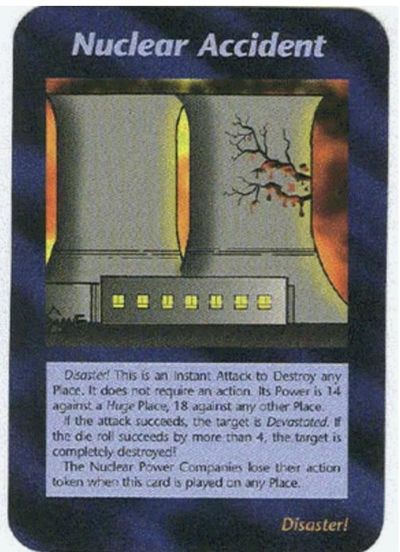

**Prediction of the Fukushima nuclear accident at the Fukushima Nuclear Power Plant on March 11, 2011?**



Detail in the card: Triangle on the girl's bracelet. No one

would suspect an unarmed runner. This card

predicted the attack that occurred at a marathon

in Boston in 2013. (31 years earlier)



As speculation and with what we have seen so far, we could understand it as that the elite wants to eliminate physical money. Why would they do this? In doing so we would have to use digital money, which would make it easier to control us. The curious thing is that this is happening (cryptocurrencies). Other details that corroborate this from the letter are that there is fire behind the bag, which would indicate that the money would “**burn**” or “**disappear**”

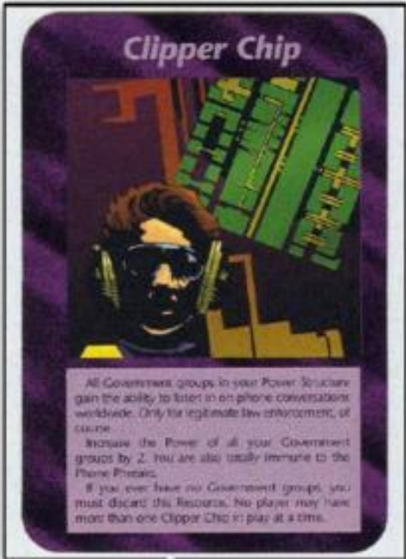

The “**CHIP**” card can be linked to the new introduction of **RFID chip**s that are now being introduced as a way of making our purchases. It is a chip that is implanted in the fleshy part of the skin, between the thumb and index finger. This would give them absolute control over the population. What happens if you choose not to have this chip? They would consider you a criminal and you would not be able to buy anything.



The most curious thing about this letter is that it is already happening too. A lot is going on in the world but who cares? We have gone from having little information to being completely inundated with it. The brain has a hard time filtering what is important and what is not, so we end up having an apathetic attitude towards everything around us.



This card is called CENSORSHIP. One of the elite's goals is to eliminate freedom of expression. The clearest example of where this card is: YouTube (there are more and more policies that restrict certain types of videos, preventing content creators from monetizing them).



“Charismatic leader.” What’s so curious about this? Who do you think this person resembles? This card seems to be the one that predicted the “charismatic” president Donald Trump. It is related

to the following:

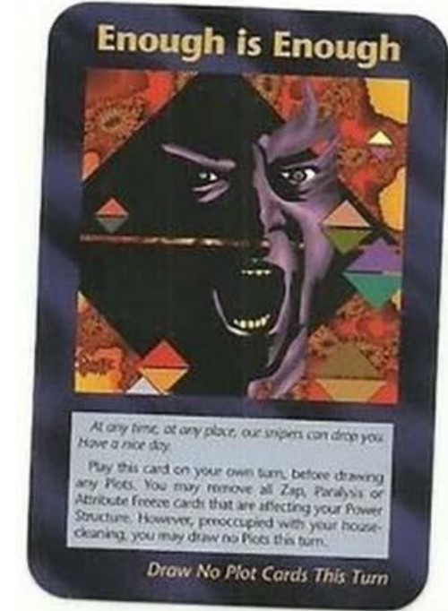

Description of the card: “At any time, at any place, our snipers could get you, have a nice day.”

With the description of this card we can understand that if Trump were to disobey what the elite requests, the solution would be a sniper.

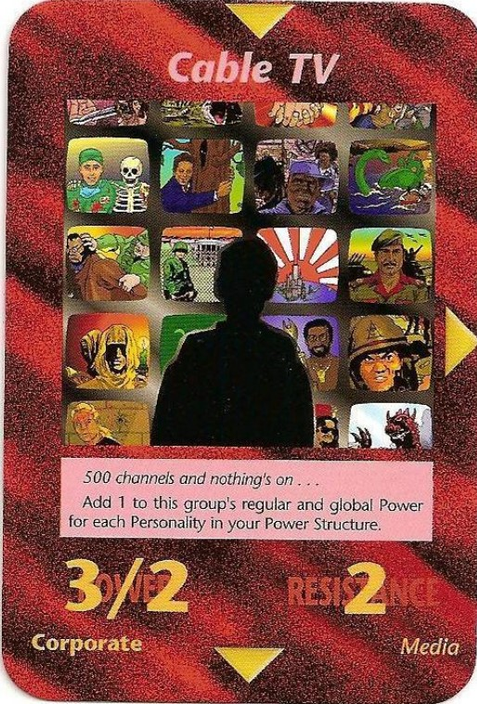

Name: Cable TV. Description: 500 channels and none of them show anything. What this means is that television channels only serve to keep people distracted and stupefied with programs that teach nothing. The elite manipulate all media outlets so that people see what they want them to see.



A DEAL YOU CAN'T REFUSE.

This card tells us that if they propose something to you, such as giving you money, fame or power in exchange for something, you already know where you will end up.



**Are we having fun yet?**

Description: Boss, this secret society thing is getting old, can we take a vacation, form a band or something? This letter would show us how the Illuminati take control of the entertainment industry in order to control the masses. A clear example of this is in trap and reggaeton where their singers are continuously making references to the Illuminati.



“**Dried up and cast aside**” This card refers to the current system where we are made to study a large part of our lives and then have to work practically the rest; this is what is meant by “dried up.” When people are no longer useful to the system, they retire, that is, they are cast aside.

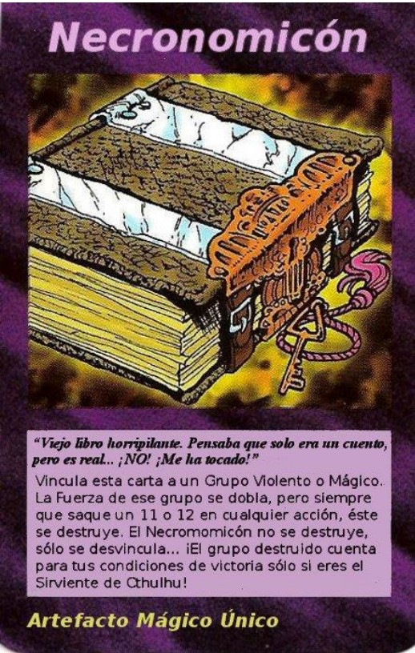

Description: A scary old book… I thought it was just a story but it’s real!... NO!

That got me! The Necronomicon is a book that is cursed. It is said to contain the power to resurrect the dead. Loosely translated, its title means “a picture of the law of the dead.” It is considered one of the most mysterious books in existence.

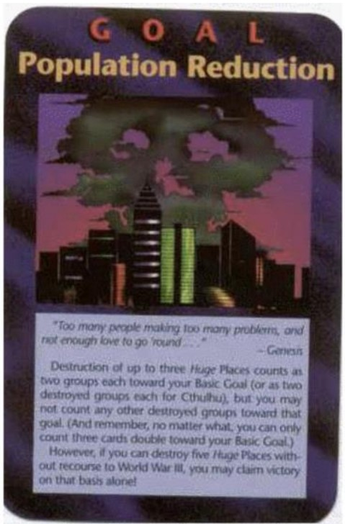

**“Population reduction”**

Description: Too many people causing too many problems and not enough love to give them… This card tells us one of the main objectives of the elite: to reduce the world population. They would do this through diseases that they themselves create in laboratories, financing pro-abortion marches and introducing fluoride into the water that would affect us in the long term.

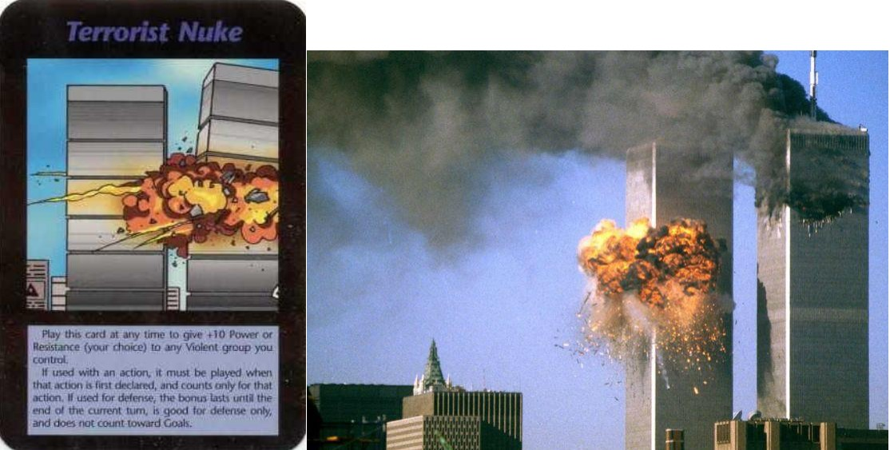

“**Terrorist Nuclear Weapon**”

Prediction of the attack on the Twin Towers on September 11, 2001? Or was everything already planned? Let us remember that the cards were created in 1994. Note that the name says “nuke”, that is, nuclear bomb, giving wings to those who maintain that the Twin Towers collapsed due to a controlled demolition and not due to the crash of a terrorist plane.

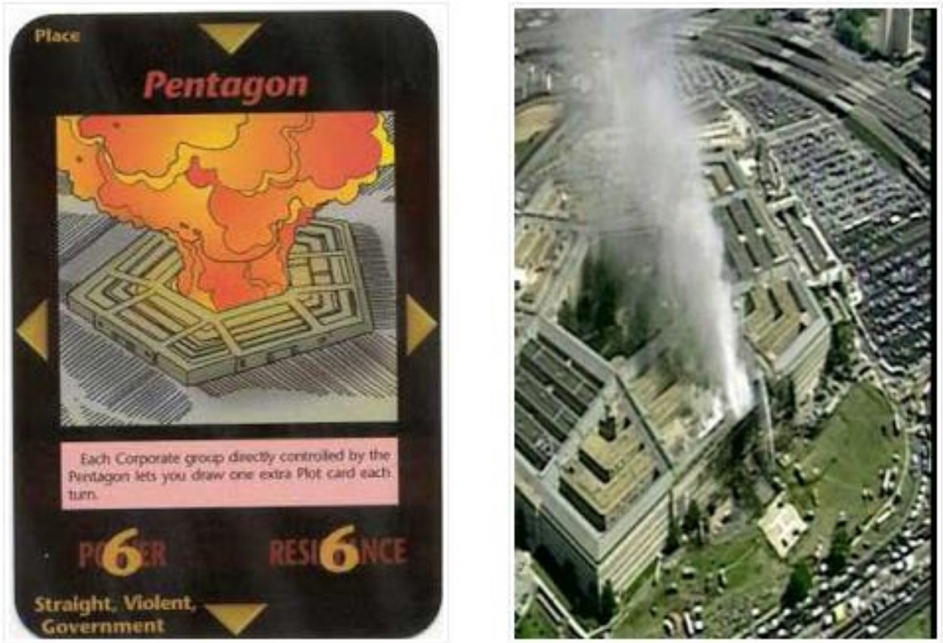

Attack on the Pentagon on September 11, 2001. Prediction or coincidence?

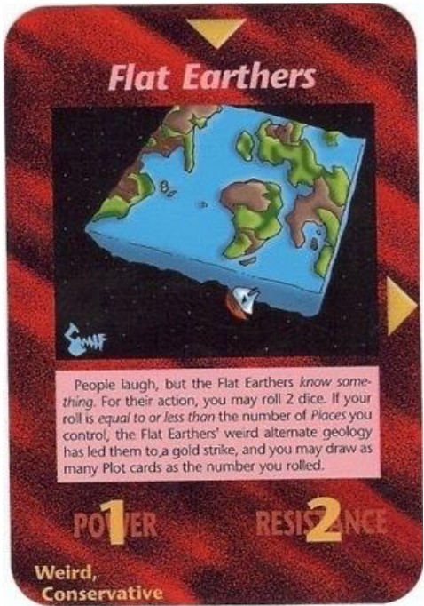

**Flat Earthers**

Description: People laugh at them. But flat earthers know something…This letter does not confirm that the Earth is flat or that flat earthers are right. What it may be saying is that some of their arguments, such as that NASA is a fraud, may be true… “they know something.” Let’s look at the next letter.

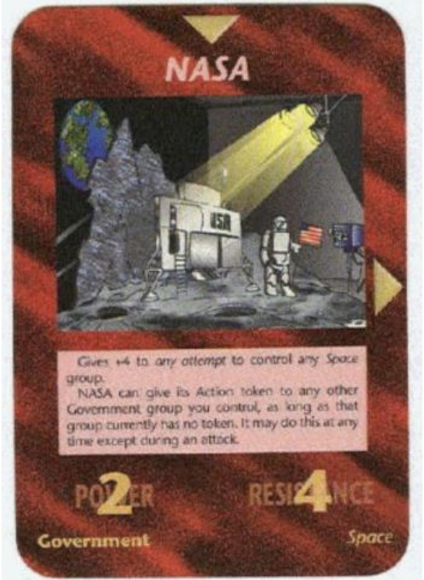

What conclusions would you draw from this letter and the previous one?



“**Rewriting History**”

There is a theory that claims that history as it has been told to us is false. It is said that all the events that have occurred were invented or slightly distorted to cover up what really happened.

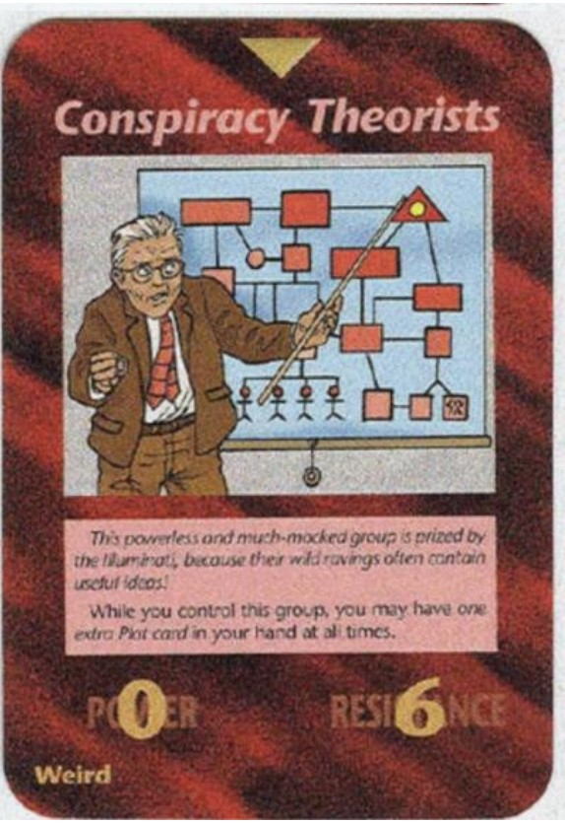

**Conspirators**

Description: This powerless and much-mocked group is appreciated by the Illuminati because some of their crazy thoughts sometimes contain useful ideas. What we can deduct from this letter are two things: first, the possibility that the elite uses some false conspiracy ideas to its advantage, and second, that it is the same elite that invents false conspiracies to cover up the real ones, as well as inventing crazy conspiracies to make the conspirators look crazy.

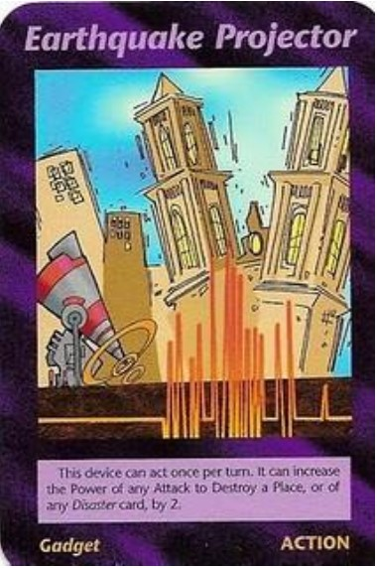

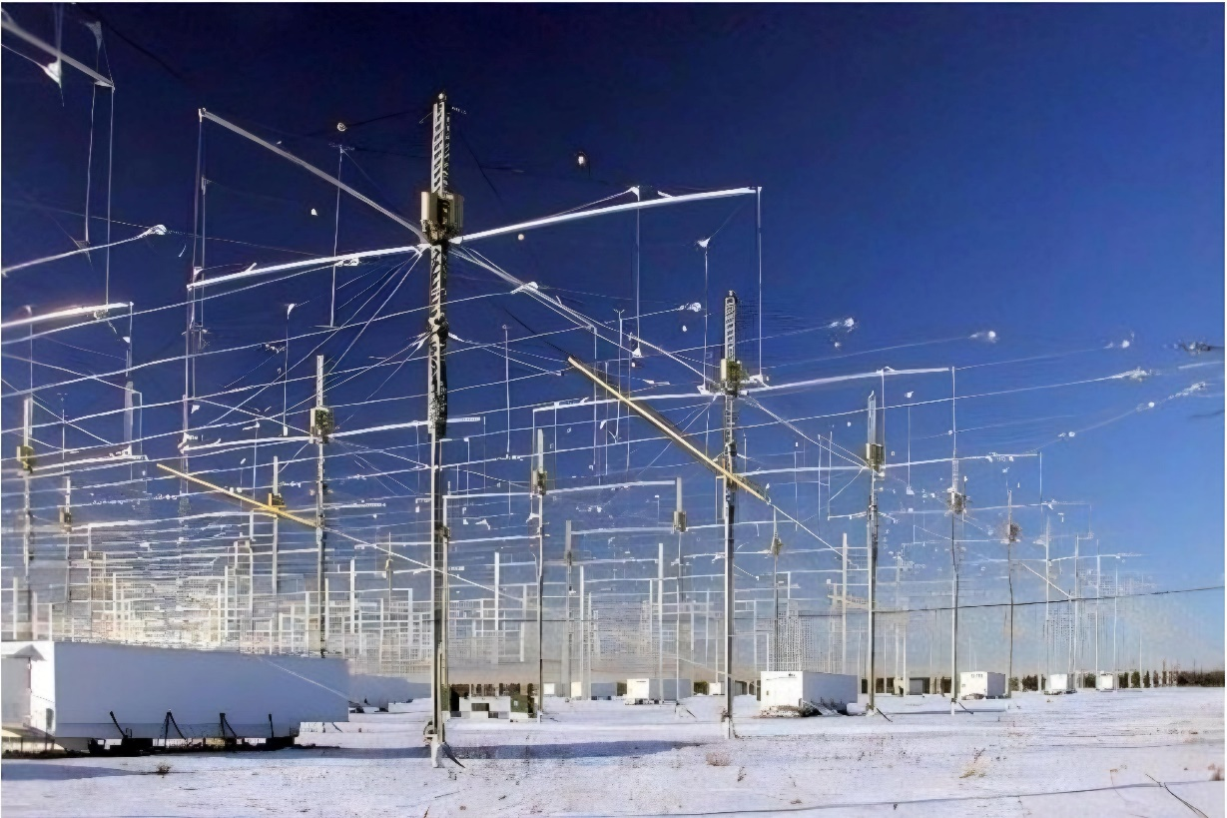

The letter EARTHQUAKE PROJECTOR refers to the HAARP project, which for many was the one that caused the earthquakes in Haiti, Chile, China, and Japan. The tsunamis referred to such a movement. This project is maintained and managed directly by the Pentagon.

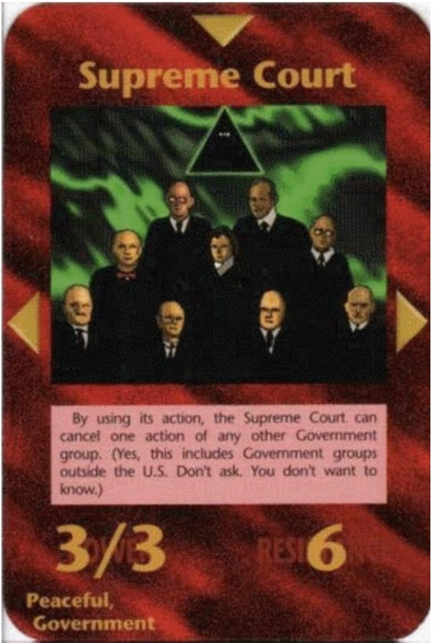

**SUPREME COURT**

Description: "By using its writ, the Supreme Court can override an action by any other government group. (**Yes**, this includes government groups outside the U.S.... Don't ask.

You don't want to know.)"



**GOOD IDEA, NOW IT'S MINE**

Facebook could be the perfect “idea” for storing personal information: phones, photos, maps, addresses, work, friends and even personal tastes. When Mark Zuckerberg was subpoenaed by the United States Congress (due to the Data Privacy scandal that arose when it was revealed that the Cambridge Analytica company (which worked for Donald Trump's campaign) improperly obtained the data of 87 million Facebook users), many theories were formulated about the strange behavior that Mark displayed. Many said that he looked like a “robot” and if you watch the videos, you

can see a peculiar way of acting, as if he were being controlled or monitored.

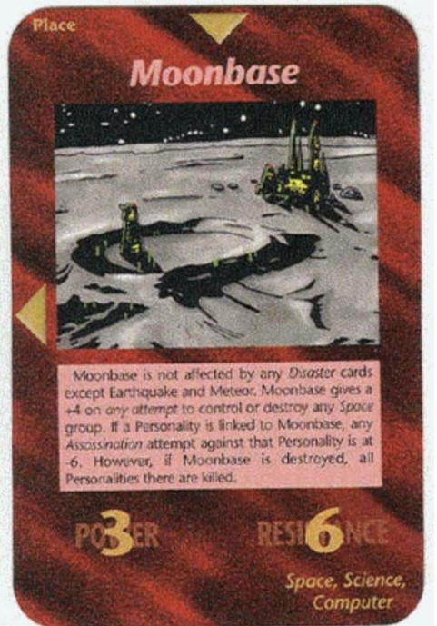

**Base on The Moon**

The reader already knows everything related to this topic.



SUMMIT/CUSIPID/TOP

Is the elite playing these cards? To finish all this and as if to say “add fuel to the fire” I leave you in textual words what a former Dutch banker and international broker who worked for 5 years in the highest financial elite in the world said:

“Everyone believes that there are good and bad in the world, but it is just a game, at the highest levels everyone works together”

“Most believe that they are there to serve and protect the people, but it turns out that they are criminal organizations, in fact, the system is criminal. We talk about creating and funding wars, basically creating misery in this world and a lot of conflicts”

“Everything we think we know in the world, is just an illusion that we believe in”

“When you get so deep into these circles you sign a lifelong contract to never reveal names of companies, organizations and people… I think that’s why I’m still alive”

“To put it carefully, most of these people followed a not very popular religion; you have Catholics, Protestants and all kinds of religions. Most of these people were Luciferian (…) they serve something immaterial called Lucifer. From the deepest part of my being, out of curiosity and love.